
Behind the scenes at the Craven Museum, Skipton

For our annual visit this year, MLHG visited the Craven Museum for a “Behind the Scenes Tour” and to view the permanent and temporary exhibitions.

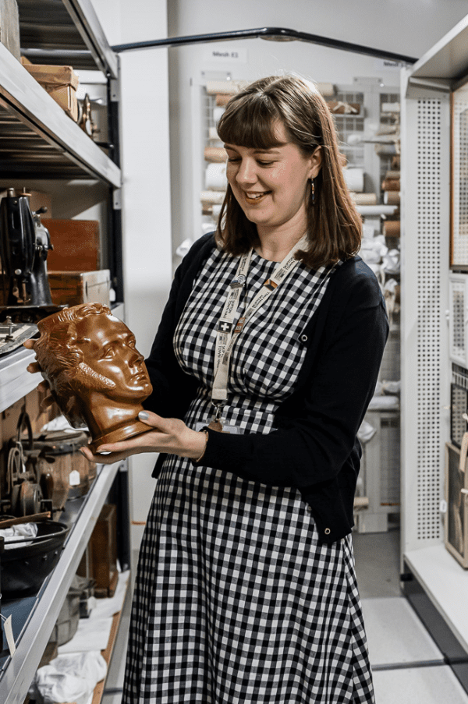
We were met by assistant curator, Charlotte, who outlined the history of the museum. Established in 1928 the museum was first housed in a room above Skipton Library. It was open from 2pm-4pm on Saturday afternoons and was staffed by members of the museum committee.

Throughout the 20th century, the museum continued to obtain new exhibits and expand its displays. In 1973, it was moved to Skipton Town Hall, and the council hired its first professional curator.

The museum moved into its current location on the ground floor in 2021, following the extensive refurbishment of the Town Hall.

As we followed Charlotte into the storage area it was noticeable that it was much cooler than outside. This is because an ambient temperature of 18C is maintained to help preserve the collections.

Charlotte had selected a few boxes to open to give us a flavour of the wide variety items held by the museum.
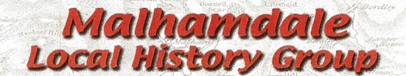

The first box contained items related to the social history of Craven. These included spirit bottles from two of Skipton’s former High St pubs - The Hole in the Wall and The Wheatsheaf. There was also a chain on a reel which was used for measuring a seam of lead and a police officer’s truncheon from Carleton.

A second box was full of ephemera The first item we were shown was a receipt given to a gentleman for payment of the wig-powder tax, which sparked off some comments about interesting ways governments find to raise money. The second item was a series of love letters, written by a man who had to leave the country for some unknown reason. He corresponded with his fiancée until his death a few years later. It seems that her letters were returned as the museum holds a complete set of letters from both parties.

In the final box we saw some of the small finds from Kirk Sink, the Romano-British Villa in Gargrave. These were donated to the museum after a dig which took place between 1968-75. There were some beautifully detailed brooches and coins. Other items held by the museum include Samian ware, glass, bronze artefacts, cheese presses and many large and small pieces of tesserae.

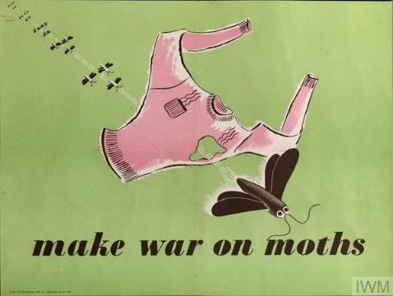
Returning into the museum the group thoroughly enjoyed looking at the posters in the temporary exhibition “Designed for War: The graphic power of Second World War posters”. The Museum holds 500 such posters, many donated by a private collector from Earby.

Photos courtesy of the Craven Museum.
Linda Hodson

