
From a small boat on Malham Tarn to sailing the oceans.

Whilst sorting through some old papers from Hanlith I came across some interesting notes about John Holden Illingworth. John was born at Hanlith Hall in 1903 and was the oldest child of Dudley and Florence Illingworth. He enjoyed a happy childhood in the Dale in the years before WW1, riding, shooting, ferreting etc. In the school holidays he enjoyed assisting the Airton blacksmith, David Bell, learning practical skills which would stand him in good stead in later life. John also developed an interest in sailing but regretted that he couldn’t find any books on the subject.

William Morkill (of Newfield Hall) gave John his first sailing dinghy which was about 9 feet long and had been used as a platform from which to shoot ducks. This was transported to Scalegill Mill where the 12-year-old John learned to sail it on the dam. John then progressed to sailing on Malham Tarn in a bigger boat provided by an uncle. This boat was kept in one of the boathouses at the tarn with the permission of Walter Morrison.

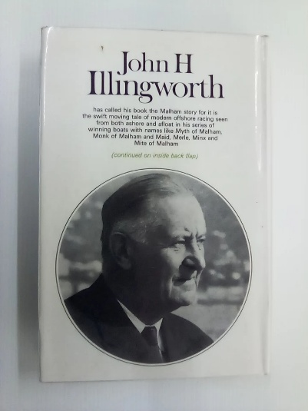
John went on to join the Royal Navy as an engineer and served for fifty years or so.
In 1927 he was appointed to the submarine flotilla in the China station. Here he tried his hand at yacht racing which was a thriving sport in the Hong Kong area and became hooked on the sport.

With his engineering background he soon set about trying to improve the design of his first yacht which he had bought for £185. He had a marvellous Chinese sailmaker who, with just an old sewing machine, could make or modify sails to any specification which greatly improved performance.


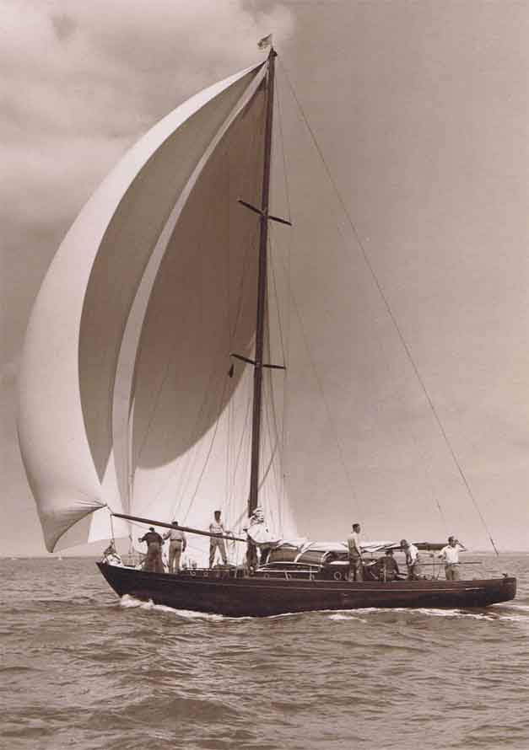
Between the wars, when back in England, John’s interest in yacht design and racing led him to set up the firm of Illingworth and Primrose. In 1936 he produced the first yacht specifically designed for ocean racing and called it “Maid of Malham”. This boat took all the prizes in the yacht races at that time. John went on to design many more “Malham” yachts. All the tillers for these yachts were made from ash trees which grew in Malhamdale.
Maid of Malham
designed by John H Illingworth

In 1946 John instigated and won the inaugural Sydney to Hobart race. On his return to England, he designed the revolutionary “Myth of Malham” which completely dominated the ocean racing scene and in which he won several Fastnet races. He went on to influence other yacht designs such as that of Gypsy Moth IV which Francis Chichester sailed single-handedly around the globe. John was even consulted by Prince Philip on the design of “Bloodhound” in which he competed very successfully.

John rose to the highest ranks during his naval career and achieved high honours in his hobby of yacht design and racing, ending up as Commodore of the Royal Ocean sailing club. He died in 1980 aged 76 and was buried in Kirkby Malham. A memorial stone can be found in the churchyard near the South wall of the church.

Linda Hodson

