
The Malham Story

Last month I wrote about John Illingworth’s contribution to the world of sailing. Whilst researching this I discovered that John had also written a book entitled “The Malham Story” which was published in 1972. Whilst this is primarily a book about his sailing career the first chapter is devoted to his early days in Malhamdale.

John writes “as a child I had virtually no schooling and so was free to roam around and enjoy myself in the countryside with the villagers.”

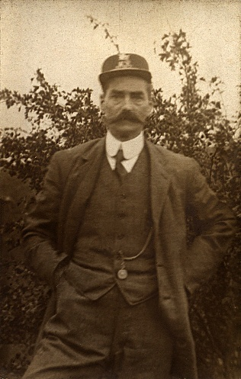
Like many young boys he got into a few scrapes. He recalls riding his pony from Hanlith to take his father’s letters to Bell Busk station one Sunday afternoon, when there was no regular post. “Somehow, I got a bit late and put Queenie into a canter. I stupidly caught my right foot in the parapet of the bridge over Otterburn Beck and came off landing plumb on my head. I remounted a bit shakily and went on to the station where nice Mr Perritt, the stationmaster, with his long moustaches and immaculate tailcoat, was on duty. His daughter was very kind, mopped my brow and gave me a cup of tea.”
Mr Perritt

As well as helping out at the Airton blacksmith’s, John liked to visit the carpenter’s workshop at Scalegill Mill where Jack Clark worked. Jack did lots of work on the estate from felling trees to making coffins for the villagers. One day John went to see if Jack could mend a broken tiller and was surprised to find Jack reclining in a half-finished coffin. Jack explained “There’s not mooch on today, Master John; I thought I’d mek meself a coffin.” John replied that he hoped Jack wouldn’t be needing it for a long time to which Jack responded “Nay, I ‘opes not, but I likes to ‘ave it by me just in case.” Jack went on to live another 30 years!


Living at Hanlith Hall, John also has memories of the wealthier inhabitants of the area and recounts several anecdotes about Walter Morrison.

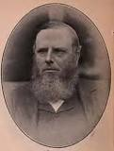
“One of my earliest memories of Walter Morrison was of him reading the lessons in church. He had a fine rolling voice and read beautifully. When standing behind the lectern, a fine bronze eagle which held the enormous Bible, Morrison was an imposing figure; well over six feet tall, his great beard, his steely eyes and his always beautifully cut tweed suit. He used to read the first lesson from the Old Testament and one felt as though Abraham himself was, in rolling measured tones, addressing the tribes of Israel.”
Walter Morrison

It was the usual custom for Morrison to join the Illingworths at Hanlith Hall after the service to have a sherry or two before driving back to Tarn house in his wagonette. He often had amusing tales to tell, including one where a newspaper had published his obituary when he was still very much alive!

Attendance at church was very much part of John’s life and he regularly attended services at St Michael’s with his father and mother.
His mother had often complained of the glare of the morning sun through the plain East window so when Florence Illingworth died in 1957 the family decided to provide a new east window as a memorial. This was executed by John Bligh who had previously designed a window for the chapel at the Naval Air Station at Arbroath when John was Commanding Officer there. Both windows were judged to be a proper mixture of holiness and artistry, albeit with a modern touch.

Linda Hodson

