
The Roman Marching Camp on Mastiles Lane

The Roman marching camp on Mastiles Lane can be easily spotted thanks to the plaque erected by English Heritage. The only oddity of the plaque is that it says “Near to where you are standing lies part of a Roman fortified camp…” The oddity is that, when you are standing by the plaque, you are actually in the middle of the camp! It spans both sides of the boundary wall which follows Mastiles Lane.
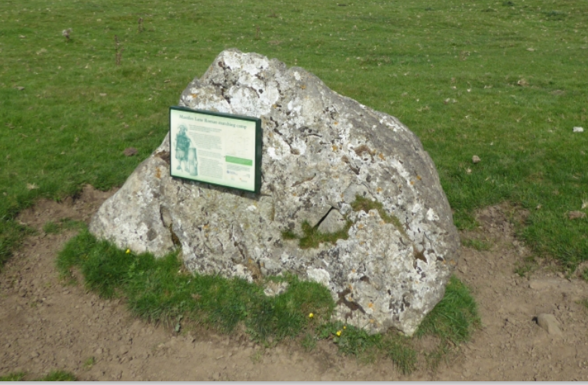
It is probable that the camp was erected in AD71 as part of the Roman campaign to subdue northern England, particularly the Brigantes tribe with whom the Romans had had increasingly difficult relations. The campaign was under the overall command of the governor, Quintus Petillius Cerialis but the chances are that this camp was erected by the XX legion commanded by Gnaeus Julius Agricola. Agricola later became governor of Britain.

It was common practice for the Roman army to erect a defensive camp while on campaign, especially in hostile


territory, even if it was for only one night. The Mastiles camp is large enough to accommodate a whole legion of approximately 5,000 men.
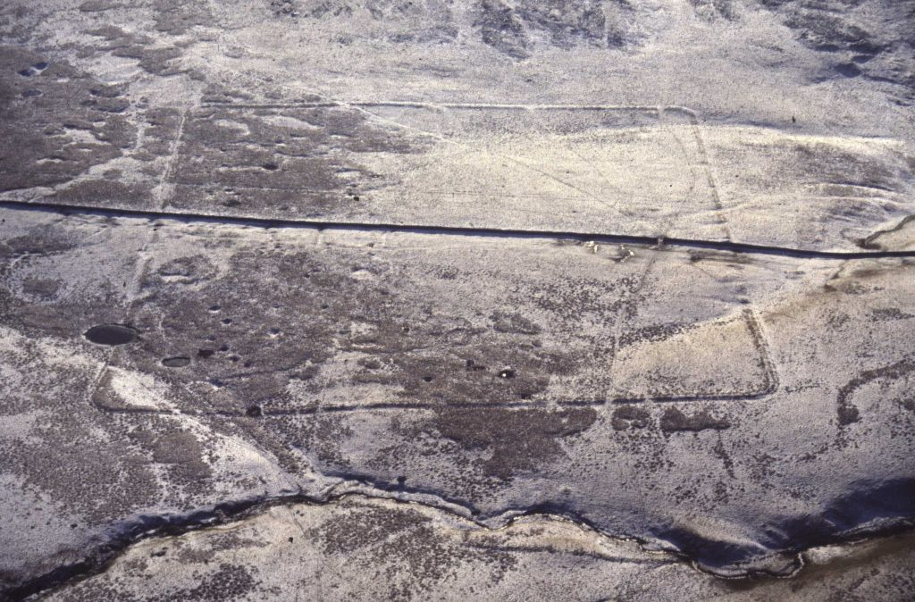

Arial view of the Marching Camp
From “Out of Oblivion” YDNPA

It would be a mistake to think of the camp as a “fort” in the same way as we might think of the US Cavalry erecting a fort to protect themselves from hostile tribes of Indians. Although the camp has a surrounding ditch and earthen rampart formed from the soil from the ditch, it was never the intention of a Roman legion to fight behind these defences. If trouble arrived, then a legion was likely to march out to meet it. Rather, the camp was a secure and well-ordered base for the night.
More info. on https://outofoblivion.org.uk/gazetteer/4574

Phill Brown

