
More from the school logbooks

Entries regarding attendance are commonly found in the early school logbooks. This was because the amount of Government Grant paid to the school was linked to attendance at that time. School Governors regularly called in to check the figures as well as attendance officers.

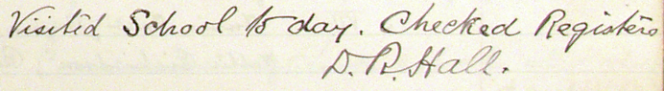

11th March 1881
“Mr Hargreaves, attendance officer, called – spoke to him about the boy HA who has been absent for some months and also about the non-payment of fees by the M family. Nothing can be done until the byelaws are sanctioned by the Department. Mr Hargreaves brought several boys back to school after 4pm for stone throwing along the road.”

Although the Education Act of 1880 made education compulsory for children between the ages of five and ten parents were still expected to pay fees. It wasn’t until 1891 that education was provided free of charge. The age of compulsory attendance at school then rose to the age of 11 in 1893 and to 12 in 1899.

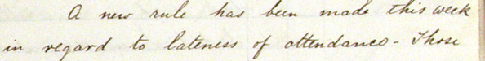
The school introduced measures to improve attendance and punctuality, starting with sanctions, then moving to rewards.


19th October 1876
“A new rule has been made this week in regard to lateness of attendances. Those who do not fall in line in time for inspection of cleanliness go to the bottom of their standard that morning or afternoon.”

8th June 1891
The Governors decided that every child making 410 attendances should be entitled to a prize and that a prize of extra value should be given to those who make within six of the possible number of attendances during the year.”

Whilst illness and the severity of the weather were the main reasons for absence the children sometimes took time off to attend local Fairs, such as Malham Sheep fairs and Long Preston hiring fairs.
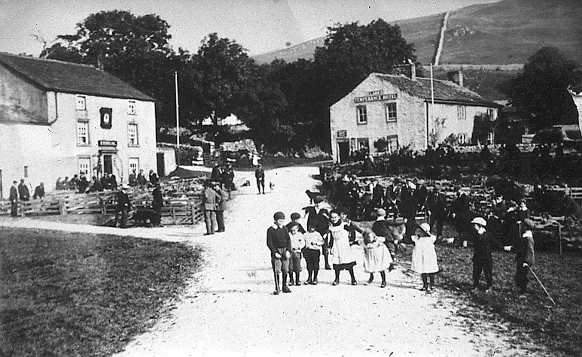

14th October 1874
“34 scholars asked leave for tomorrow being Malham fair, according to their parents’ wishes.”

1st March 1883 “Today being “hiring day” at Long Preston a great many of the older boys were absent.
Linda Hodson

