
Revd. John Pering’s tour of the Lake District in 1808.

Revd. John Pering was appointed vicar of both Skipton and Kildwick in 1806. Having previously lived in rural Devon, he opted to live in Kildwick rather than Skipton where the vicarage faced onto the busy High Street.

Local historian, David Turner, found a copy of Rev. Pering’s journal in the archives of the Wordsworth Trust. Within it he found a very detailed account of a visit to the Lake District in 1808 made by Rev. Pering, his sister Lucy and three close friends from Devon. All five travelled in Rev. Pering’s two horse chaise, which he drove. Travelling about 35 miles a day, it took them two days to reach the Low Wood Inn near Ambleside, having stopped overnight in Kirkby Lonsdale.

On their first day they took a boat trip on Windermere and the following day travelled over Hawkshead Hill to Coniston. Having taken his fishing rod with him, Rev Pering records that at Coniston he ‘caught a few perch’.
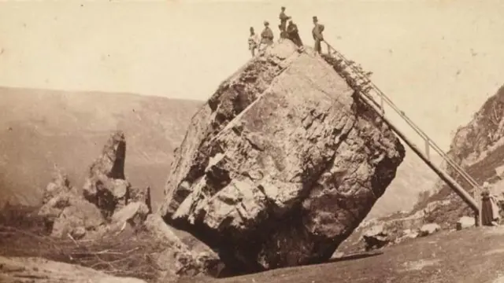
The party moved on to Keswick from where they made several excursions, including one to the Bowder Stone in Borrowdale.



Rev. Pering had a strong desire to reach the summit of Skiddaw so booked a guide to accompany him and his three friends. The party set off at 5am. The journey to the top was made quite easily on Galloway ponies. However, the descent was more precarious, forcing the riders to dismount and continue on foot. Nevertheless, they managed to return to their lodgings in time for breakfast,

The next day, parting from their friends, the Perings journeyed on to Grasmere to visit William Wordsworth and his family.

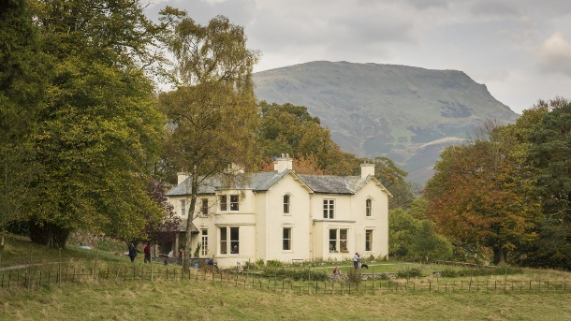
The Wordsworths had recently moved from the cramped Dove Cottage to the much larger Allen Bank (now a National Trust property) which had originally been built for a wealthy Liverpool merchant.

Rev. Pering recounts how he and Wordsworth climbed the hill behind Allen Bank and discussed various issues of the day. Wordsworth revealed that he had recently completed an epic poem set at Bolton Abbey titled “The White Doe of Rylstone”. This became one of Wordsworth’s best-known poems in the 1800s and brought many tourists to Bolton Abbey.

From Grasmere, the Perings returned home, having been away for two weeks. Rev. Pering remained as the vicar of Kildwick and Skipton until his death in 1843. He is buried in Kildwick Church where there is a plaque to his memory.
Linda Hodson

