
Arthur Raistrick – scientist, polymath and lifelong rebel.

In May, Colin Speakman introduced us to the fascinating life-story of Arthur Raistrick, a man of many talents.

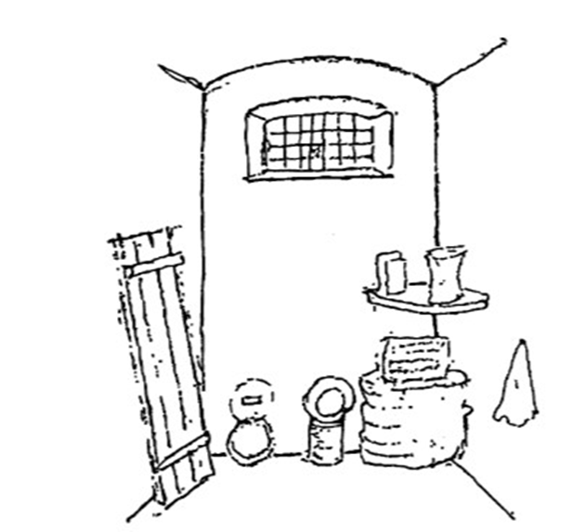
Born in Saltaire in 1896, in a small, terraced house to working class parents, he won a scholarship to Bradford Grammar School but left at 16 to become an apprentice at a local electricity works.

At the start of World War I, as an already committed socialist and pacifist, he refused to either serve in the armed forces or a reserved occupation and became a conscientious objector. Though still a teenager, he was court martialled and forced to spend the war years in Wormwood Scrubs and Durham Gaols, an experience that led him to become a lifelong Quaker. He was only finally released in 1919 after four years behind bars.

After the war Raistrick was finally able to take up a scholarship to Leeds University, which enabled him to take a first degree in civil engineering and a doctorate in geology. Still unable to get a full-time job, he undertook research projects, mainly in mining geology in the Nottinghamshire and Derbyshire coalfields and taught a variety of adult education classes. In 1929 he was finally appointed as a lecturer in geology at Armstrong College, Durham, later part of Newcastle University.

From 1939 onwards Arthur and his wife Elizabeth lived in the village of Linton-in-Craven near Grassington. Raistrick’s lectureship was suspended during WW2 so the couple sustained themselves by writing
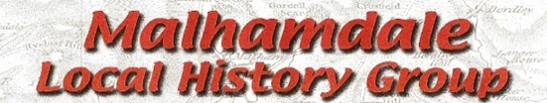

and teaching. This included a whole series of articles by Arthur in the newly established Dalesman magazine. He even produced a national guide to basic geology in the popular Teach Yourself series.

Travelling by train, bus and foot he also gave WEA classes and talks in various villages in and around Skipton, including Malham.

Between 1941and 1944 Raistrick was also a regular visitor to Kirkby Malham where his friend and fellow Quaker, the architect John Dower was living. Raistrick worked closely with Dower on his report about the future of the British countryside. This document was to form the basis of the great National Parks and Access to the Countryside Act 1949 which in turn led to the setting up of Britain’s network of National Parks.
Raistrick can truly be regarded as one of the Founding Fathers of the UK National Park movement and of the Yorkshire Dales National Park in particular. For many years he was President of the Ramblers Association and certainly was one of greatest campaigners for public access rights of his time.

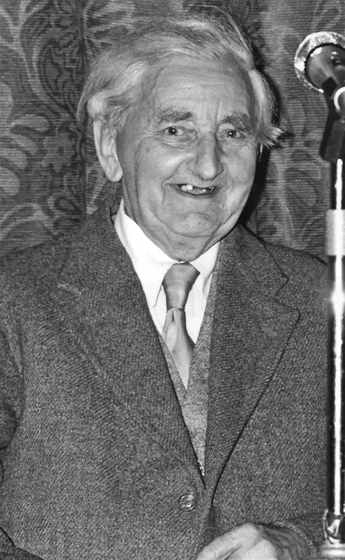
Raistrick’s achievements as a scientist are also now recognised by scientists as being of major, national importance. His work on Dales’ glaciation in the 1930s was groundbreaking and he was also a world pioneer of the modern science of palynology, the study of fossilised pollens. Equally, his many books and lectures on landscape history, archaeology and industrial archaeology inspired and motivated later generations and continue to do so.

In 2000 the Yorkshire Dales Society honoured the memory of Arthur Raistrick by naming him Dalesman of the Millennium.

