
Februarys Past – extracts from the school logbook

As Kirkby in Malhamdale United School celebrates its 150th year I thought it would be interesting to start the year with extracts from the school logbook. All entries were recorded in February of a particular year.
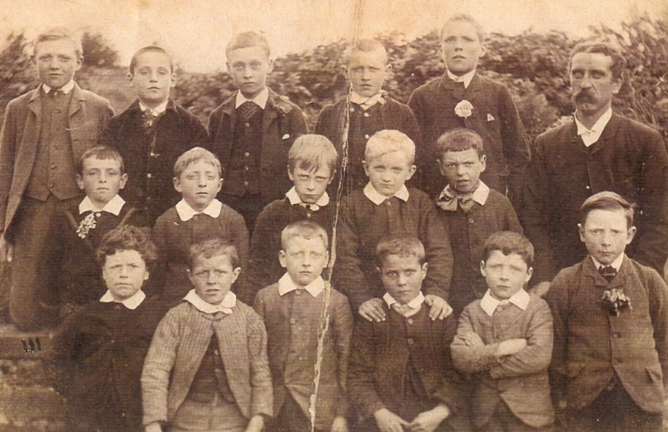

Master and boys in 1896
Inclement weather and its impact on attendance were often reported.
Monday 3rd February 1879
“Another fall of snow yesterday, providing the boys with abundant ammunition for snow balling. But the sport resulted in a broken pane of glass in the boys’ lobby. The Master made a most careful investigation at 4 o’clock but failed to find out the author of the mischief. No-one appears to have seen the snowball thrown at the window or would not bear witness. So, the matter remains a mystery. A severe reprimand and a caution were given to three boys who were playing nearby.”
Cold weather was often accompanied by illness, resulting in poor attendance and school closure. Common diseases mentioned include whooping cough, measles, chicken pox and influenza. Two children were also excluded for having ringworm.
13th-20th February 1887
“Severe snowstorm yesterday – only two children came to school this morning. No school all day. Miss Turner still absent; she now has the chicken pox. Twenty-five children have now had chicken pox and five more are now away from the same cause.”
24th February 1919
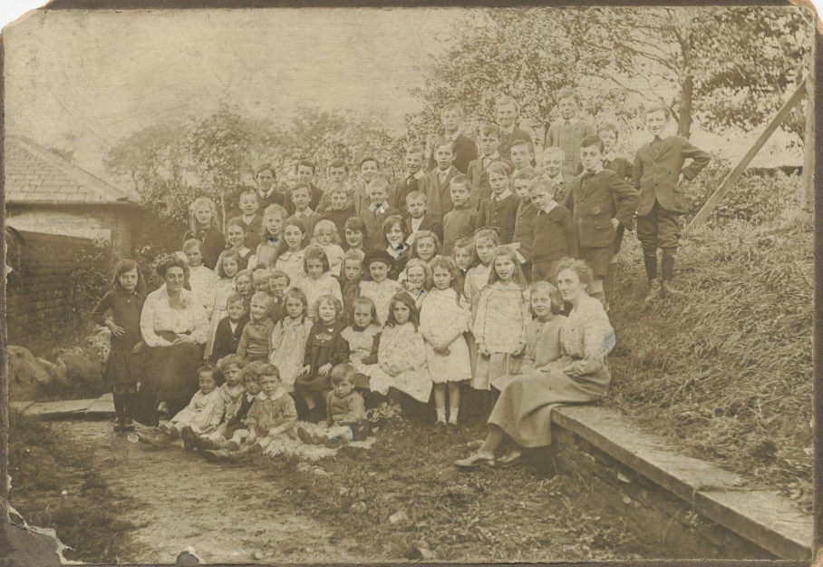
“The Medical Officer of health has ordered the school to be closed for a fortnight on account of influenza.”

School group 1919
Sadly, some children died from these illnesses. The funeral of a scholar was recorded on February 14th, 1918. “This kept a number of children away”. The scholar in question was Jane Annie Simpson of Hanlith who was aged 12. Rev. Hall officiated at the funeral in Kirkby Malham.
Linda Hodson
For details of MLHG’s next talk see p.

