
A special Otterburn Lodge Christmas
By Avril Harwood (1934-2025)

Last year MLHG received an account, written by Avril Harwood (nee Caton), of a very special Christmas in 1945. We are delighted to share some of Avril’s memories in this edition of the Parish News, as a tribute to Avril who died in April 2025.

Although WW2 had ended, not all prisoners of war had been repatriated from the prisoner of war camp in Skipton. Some were sent to work on local farms until the time came for them to return home. The Catons received four such prisoners at Otterburn Lodge who remained there till January 1946. Avril had fond memories of that time and especially of that Christmas.

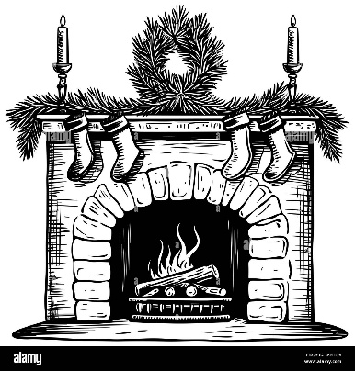
December came, and then, it was Christmas! This was always a busy time on the farm. There was the work with the dairy cattle at the barn, but there were also two dozen geese to pluck and dress and deliver to customers. It always seemed like a lot to accomplish by Christmas Eve. But when Christmas morning came our stockings were always full, with an orange in the toe, a spiced, hard sugar pig with a pink curly tail, books, and toys.

Soon after church, my sister Vivien and I would set the dining room table for our Christmas dinner. My mother had filled a box with special Christmas food and treats for our German friends.

A few days before Christmas, they had surprised us with an invitation to join them the evening of Christmas Day for tea and biscuits in their cottage. We all looked forward to this. The cottage was a short walk


way through Otterburn village. When we arrived, there was a welcoming fire blazing in the fireplace, chairs set in a circle, and plates of biscuits on a side table waiting to be handed around along with tea.

In a corner was a small fir tree, beautifully decorated with silver shapes of stars and circles and half-moons. Hans, the schoolteacher, had made them from empty fruit cans. I cannot imagine how he managed to flatten the cans so well and cut the tin so carefully into the lovely shapes hanging on the tree and glinting in the firelight. Again and again, our eyes turned to look at the lovely little Christmas tree.

After numerous cups of tea, lots of biscuits, and plenty of talk, Hans got up and moved to the pump organ that sat next to the fireplace. The small organ had been put there a few years earlier, when the room was used for the village Sunday School. As Hans sat down and began to play, the other three men stood up and sang for us, in the original
German, the lovely carol “Silent Night, Holy Night.” We were enchanted. My mother Betsy had a good voice so she could lead us in the carols we knew well. Hans picked up the tunes right away and played along with us. I can remember three of the carols: “While Shepherds Watch Their Flocks By Night”, “Hark the Herald, Angels Sing”, “Away in a Manger”, and a few others.
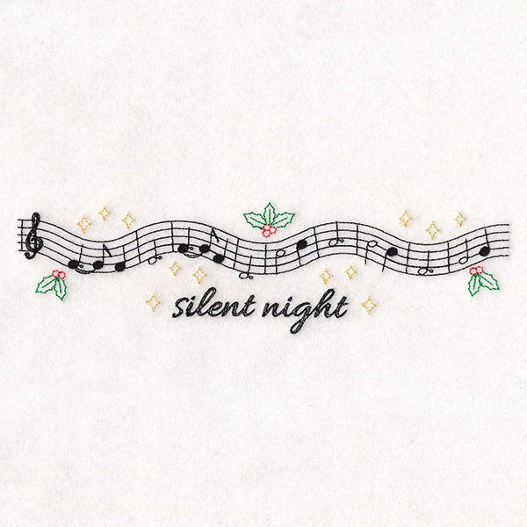

It was a wonderful evening. We had little to give each other except kindness and companionship, but it was enough to make it a very special Christmas Day.

