
Half-timers – a mix of school and work

In 1878, soon after Kirkby in Malhamdale United School opened, a new law was passed to ensure that 10 to14 year olds could only be employed on a half-time basis. “Half-timers” would attend school in the morning and then start work in the afternoon or vice-versa. Although the school leaving age increased over time, it was well into the twentieth century before the practice of half-time working ceased altogether.
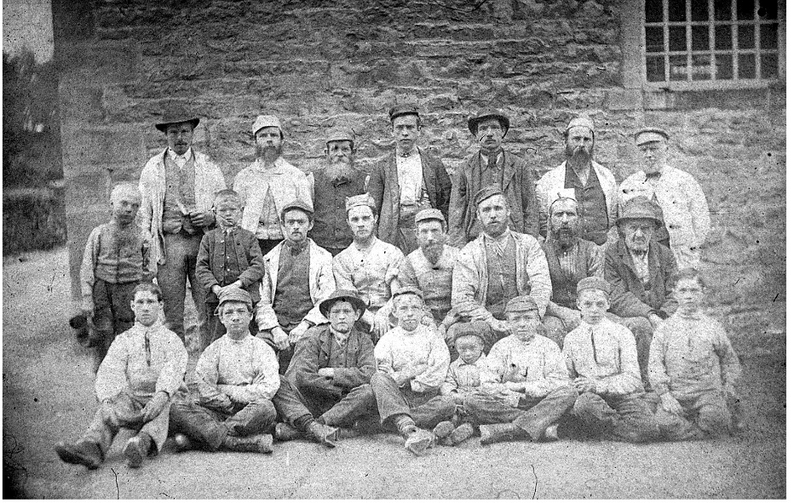
Records for 1896 show that there were approximately 63,000 children working in textile production in England, with two thirds of those being found in Lancashire and Yorkshire. Whilst Airton and Scalegill Mills were in decline by that time we know they had previously employed children.
Airton mill workers c. 1850

Records from Airton Mill confirm that half-time working had been common practice well before 1878, when cotton production had been at its height.


In1850 there were 10 half-timers who were employed as doffers, roving carriers, bobbin setters and piecers. Their wages were less
than half that of a full-time worker, so the practice found favour with employers.
Doffers unloaded the full bobbins from the spinning machines whilst bobbin setters inserted empty bobbins. A roving carrier would take roving (rolls of carded wool) from one machine to another to continue the yarn making process. Piecing required a little more skill as a piecer had to mend broken thread.
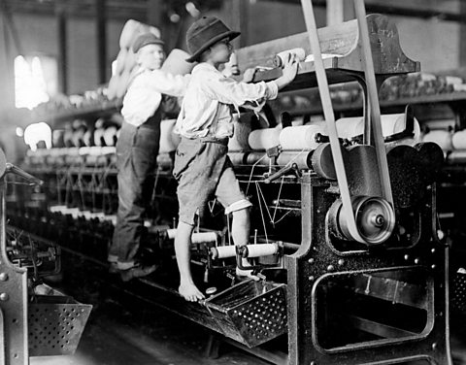
All the work required the children to come into close contact with the machinery, so it was dangerous work.
The 1851 census for Airton / Scosthrop lists three children aged 9 to 11 working at the mill. John Slater and Mary Ann Metcalfe worked as cotton spinners, whilst Mary Ann’s younger brother Henry was a doffer.
Records from Kirkby in Malhamdale United School confirm that there were half-timers at the school.
2nd February 1880 – Walter M returned to school as a half timer.
1885 (admissions register) – Edwin G has gone full-time at the mill.
At times there were clearly some tensions between the school and workplace as these entries in the logbooks show.
Fri 25th May 1877 – Two half-timers have not been at school this week. The Master sent a note to Mr Hartley at Scalegill to that effect.
18th March 1878 – No Mill Book sent in which to put the attendances of the half-timers.
The Elementary Education Act of 1891 led to the eventual decline in half-time working, as elementary education became free for all children up to the age of 14. This coincided with a reduction in cotton production in Malhamdale leading to the closure of the two mills.
Linda Hodson

