
The Rev. T.A. Leonard – Holiday Pioneer
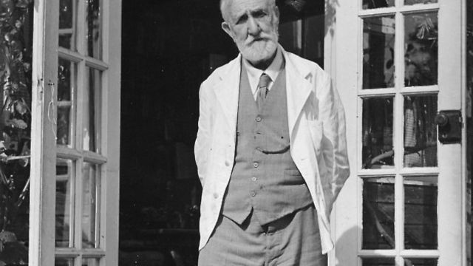
Most of you will have driven past Newfield Hall and seen the sign for HF Holidays. But have you ever wondered about the origins of the group? Originally known as the Holiday Fellowship, it was established in 1913 by the Reverend Thomas Arthur Leonard, a minister from Colne. Known as the father of the British outdoor holiday movement, Leonard dedicated himself to providing healthy, refreshing breaks for northern workers.
The organisation aimed to provide an all-inclusive holiday for the price of an average weekly wage. The first British holidays operated in 1914 at Conwy, the Lake District and the Yorkshire Dales. Holidays in Germany were also arranged – in hindsight not the best choice of location in 1914! Two Holiday Fellowship customers found themselves stranded in Kerkheim, Germany, when the First World War broke out, and spent the rest of the war interned there. Nevertheless, the Holiday Fellowship had established itself as a pioneering provider of foreign holidays. After the war ended it continued to prosper and extended the number of destinations at home and abroad.



By the end of the 1920s it had 23 houses in the UK and nearly 30,000 guests. At this time the society responded to queries from female guests and produced a pamphlet on ‘Dress Hints for Ladies’. It advised lady walkers to “wear strong, low-heeled boots, woollen stockings, short skirt, close fitting hat or cap, and in summer a light scarf or handkerchief for the head, a woollen jumper and light macintosh or poncho”. It added that “complete changes of underwear, and plenty of woollen stockings are essential”.
Leonard continued as General Secretary of the Holiday Fellowship until 1934. In the 1930s he also helped create the Youth Hostels Association and was one of the founders of the Friends of the Lake District. He also chaired the first national meeting of the Ramblers’ Association in 1935 and helped set up the National Trust. Leonard died in Conwy in 1948 but his legacy lives on today and is still very evident in Malhamdale.
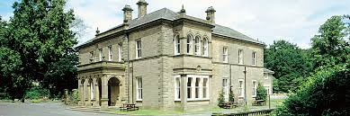

Today HF Holidays, a co-operative society with almost 35,000 members, is the UK’s largest walking holiday company. Its 19 country houses have evolved to offer the comfortable en-suite bedrooms that guests expect today. Newfield Hall, acquired by the group in the 1930s, is one of the group’s “flagship” sites and attracts many visitors each year. Over a hundred years on, holidaymakers are still benefitting from the vision of the Holiday Pioneer and can now choose from 113 destinations in 46 countries all over the world.
Compiled by Linda Hodson
Details of MLHG’s next talk can be found on page…

