
Airton’s “Tin Tabernacle”
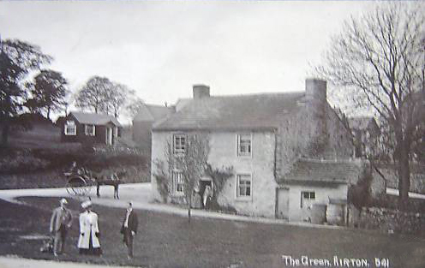
In August we spent an enjoyable evening finding out about some of Airton’s buildings and their occupants, based on the recollections of Jo Smith. It was amazing how many new buildings and change of uses there had been in Airton during her lifetime. One building that has been demolished is Airton’s former Reading Room, affectionately referred to by some as the “Tin Tabernacle”. This temporary building stood across the road from The Green for nearly a hundred years. See below.

During the nineteenth century most rural communities had a Reading Room. The townships in Malhamdale were no exception.
In 1904 the Rev DR Hall wrote: “There are four reading rooms which are useful places, where men may go to see the daily newspapers and spend hours of the long evenings in winter in conversation, reading, games etc.”
Non-conformists and Temperance movements particularly valued the opportunity for sober education provided by the Reading Rooms, which provided a place for working men to socialise without the temptations of the local inn.


The original Airton Reading Room opened in October 1873 and was housed in a room rented for £1 a season. It was open from October to March in the evenings. It operated until 1904 when a Scosthrop Reading Room was opened with virtually the same committee.
The Airton New Mutual Reading Room was opened in the same year. It was housed in the “tin tabernacle” style, corrugated iron cabin erected specially for the purpose. These cheap, flat packed iron buildings were often used for newly established missions and churches and cost around £250. How Airton raised the money for this building is unknown, but this new building was independent of the Church and was open all year round.
In 1913 the subscriptions for ordinary members were 5s per year and 10s for honorary members. These modest charges made it accessible for most of the working men in the community. The building continued to operate as a Reading Room until 1932, though only in the winter months. Does anyone know what happened after that?
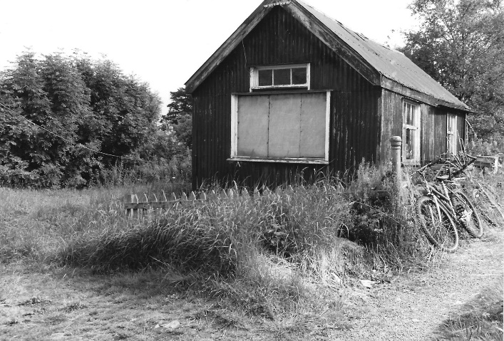
The building was finally demolished in 2000 after falling derelict.
If you have any memories of activities taking place in the building during the twentieth century, or any photos, please do let us know.
You can read more about Malhamdale’s Reading Rooms on our website www.kirkbymalham.info
Linda Hodson
Details of MLHG’s next talk can be found on page

