
Lime Kilns: their heritage and history

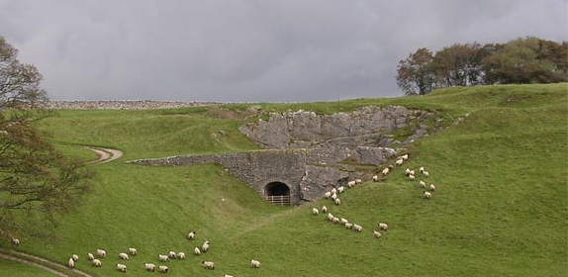
Lime kilns are a common feature in our local landscape, so it was a pleasure to welcome Dr David Johnson to speak to us on this subject at our October meeting.
The lime kiln pictured above is a well-preserved late 19th century draw type lime kiln. Sited near to Kirkby Gate it was ideally situated to exploit the limestone outcrops all around it. A small-scale commercial lime kiln such as this one was built to burn limestone for local use. The quicklime produced was slaked with water to produce calcium hydroxide (slaked lime). This was mostly used to improve grassland by reducing the acidity of the soil, especially of intake land or reclaimed moorland during the enclosures of the 18th and 19th centuries. Slaked lime was also an important ingredient in making lime mortar. The Kirkby Gate kiln seems to have been relatively short-lived since the quarries around it are small. Its owners probably couldn’t compete with the more efficient and advanced production elsewhere, for example the Hoffman Kiln at Craven Lime Works 5 miles to the West.
Source: David Johnson.
You can learn more about the industrial production of lime at the former Craven Lime Works by visiting and taking a self-guided tour. For more information see https://www.visitsettle.co.uk/craven-lime-works.html


A lot of effort went into producing lime!
When limestone is burnt in a kiln just over half is converted to lime. The rest escapes as carbon dioxide or monoxide. So, for every ton of lime produced you would have had to quarry two tons of limestone. You would have also needed half a ton of coal.

It’s a whitewash!
When lime was in plentiful supply far more buildings in Malhamdale would have been white, as can be seen in the photo below. In some examples there might be an exterior coat of render – a protective coat of lime and pebbles, sometimes with animal hair and sand added. Otherwise, stone was coated with whitewash or limewash which was used like paint. Tallow or boiled oil could be added to the mixture to make it waterproof.
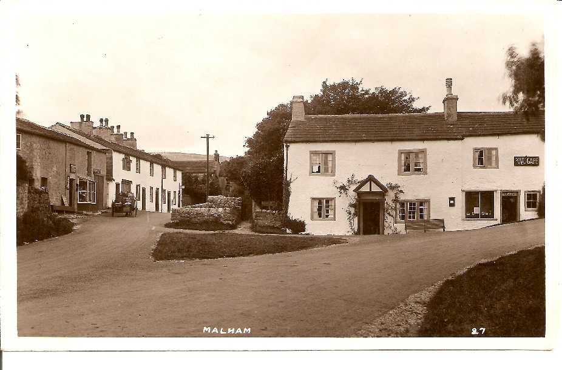

Fun facts:
- The showbiz phrase “in the limelight” comes from when theatres were lit by lime lamps.
- The Romans made and used limewash but believed it should be left for seven years before use.
Linda Hodson

