
God Save The King
Following the death Queen Elizabeth 11 on 8th September, her eldest son Charles ascended to the throne and became King Charles 111. Charles was the longest-serving heir apparent in British history, a position which he held for 70 years. At the age of 73, he is also the oldest person to assume the British Throne.
It will not be long before we begin to see the King’s image featuring on our stamps and coins.
The design for new coins, featuring the King’s head has already been released by the Royal Mint. A commemorative set, comprising £5 and 50 pence coins, is now on sale, with 50 pence coins due to enter general circulation in December.
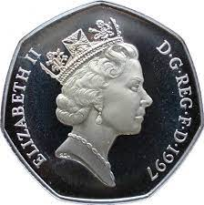
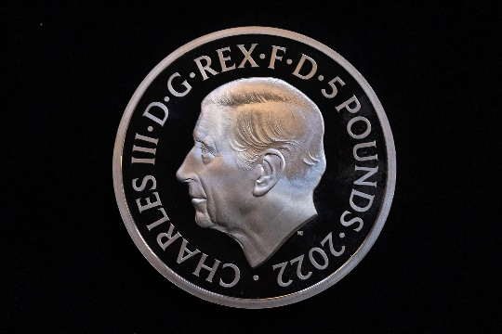

The portrait of the King’s face will face to the left, the opposite direction to the effigy of his mother, which faced the right. This shifting of direction from monarch to monarch has been a tradition on coins from the time of King Charles 11 onwards, the exception being during the brief reign of Edward V111. King Charles is also portrayed without a crown, in the same way as his grandfather and other male monarchs.

Royal Mail has confirmed that the King’s head will feature on all our stamps “in due course” once existing stocks have been exhausted.


In the days following the Queen’s death many of us recalled a time when we had seen her Majesty in person, even if it was only for the briefest of glimpses. I am sure others will have similar memories of meeting or seeing Prince Charles. He has been a regular visitor to Yorkshire over the years and has taken a keen interest in agriculture and rural affairs.

On a visit to Craven in 2004, Prince Charles caused quite a stir when he arrived at Skipton Station, sporting a cut nose and two sticking plasters on his thumbs. He is reported to have told officials that his injuries were the result of “an altercation with a hedge”.

Prince Charles was greeted by civic dignitaries before going on to visit Skipton Auction Mart where he officially opened a new educational and business complex run by Craven College.
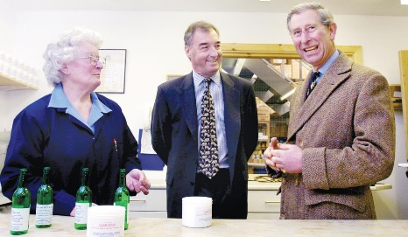
During the visit Prince Charles received an unexpected gift from Margaret Throup of Embsay. Margaret had worked for Laycock’s agricultural chemists since 1986 and two years later took over the making of their special "udder cream” using a secret recipe. She presented the Prince with a tube of the cream, saying “It is very good for gardeners’ hands.” Prince Charles joked that it was a very appropriate gift in the circumstances.

We wish our new King well at the start of his reign and look forward to his first visit to Craven in his new role.
Linda Hodson

For details of MLHG’s next talk see page

