Parish Magazine, March 2022
Malhamdale Local History Group Archive
MLHG has an archive of material of historic interest relating to the eight townships of Malhamdale plus Bell Busk, Coniston Cold, Eshton, Winterburn and Bordley that is our area of interest. It was begun by Monica Jenkins and grew substantially when David Tippey’s personal collection was incorporated after his death in 2011. Since then it has continually increased, mostly by donations but also by a limited number of purchases. It consists of photographs, postcards, letters, maps, deeds, newspaper cuttings etc. plus a small number of books. The collection is divided into our Physical Archive of actual items, mostly paper, and our Digital Archive of electronic copies, transcripts, scans and digital photographs. We are always keen to receive additions by donations or as short term loans that we can scan or photograph.
The archive is accessible for research purposes on application to the archivist.
Three quite different recent archive additions may be of interest to readers:
Clark’s Temperance Hotel Postcard.
Clark’s Hotel, was established in the late 19th century and occupied the building roughly opposite the Lister’s Arms facing towards the bridge in Malham. The building subsequently became The Malham Café until its closure in 2001. This postcard was of particular interest to MLHG, partly because of the early date (postmarked 1907) and the fact that there is a group of around 20 people posing for a photograph outside. They are dressed in typical late Victorian/Edwardian “Sunday Best” with most of the women wearing straw boaters as if for a celebration.
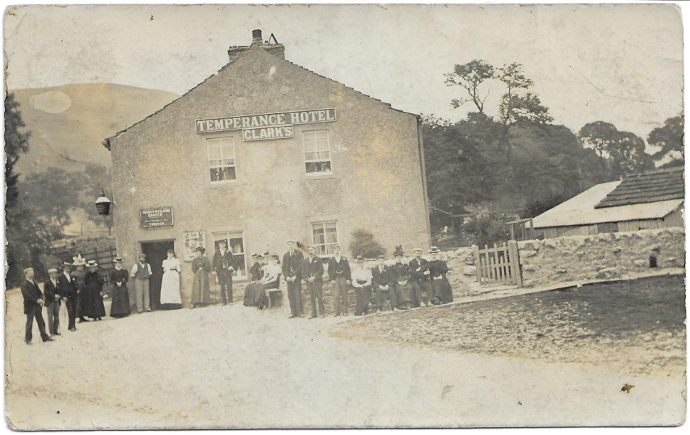
Turning to the other side we are able to identify both the writer and the recipient. The writer is Annie Opie (aged 30), a domestic servant for the Atkinsons at Hill Top in Malham. The recipient is Miss J (Janie) Banks (aged 22) from Capon Hall. A comment on the card by Annie: “Do you know this P.C.” hints that this was a local group who Annie knew. It’s a long shot but if any reader can identify the group from old family photos that would be great. Please let us know.
Airton Parish Meeting Papers.
During last year a large quantity of papers from the Airton Parish Meeting were loaned to the archive by the Meeting Secretary. These included minute books, account books, maps, plans, correspondence, etc. dating back as far as the late 19th century. The majority of these have been photographed or scanned, a total of over 800 individual pages. This collection now forms part of MLHG Digital Archive and the original papers together with a digital copy have been returned to the Meeting Secretary. Collections such as this provide a fascinating window onto the social history of their time apart from holding information on boundaries, land and property ownership, footpaths and other matters.
Church Annual Reports
In recent months we have received two donations of copies of Kirkby Malham Church Annual Reports from the late 19th and early 20th centuries. These incorporate an annual letter from the vicar, detailed reports of various church and other funds, lists of baptisms, marriages and burials, that provide a fund of information about life in Malhamdale. Over the years these became The Malhamdale Magazine and ultimately this Malhamdale Parish News. If any reader has tucked away other copies and would be willing to donate them or to loan them for us to scan please do get in touch.

