
From Wigtown to Malham – Bringing Home the ‘Natural Curiosities’

Last October half term we visited Wigtown in S.W. Scotland, to peruse the famous second-hand bookshops and take in this lovely small town. In the largest bookshop I spotted a high shelf labelled ‘Yorkshire and the Dales’, so climbed a library ladder and nearly fell off again! My jaw dropped as I realised that I was holding an original copy of Thomas Hurtley’s ‘A Concise Account of the Natural Curiosities of the Environs of Malham, in Craven, Yorkshire’ 1786. After months of haggling I secured the book!
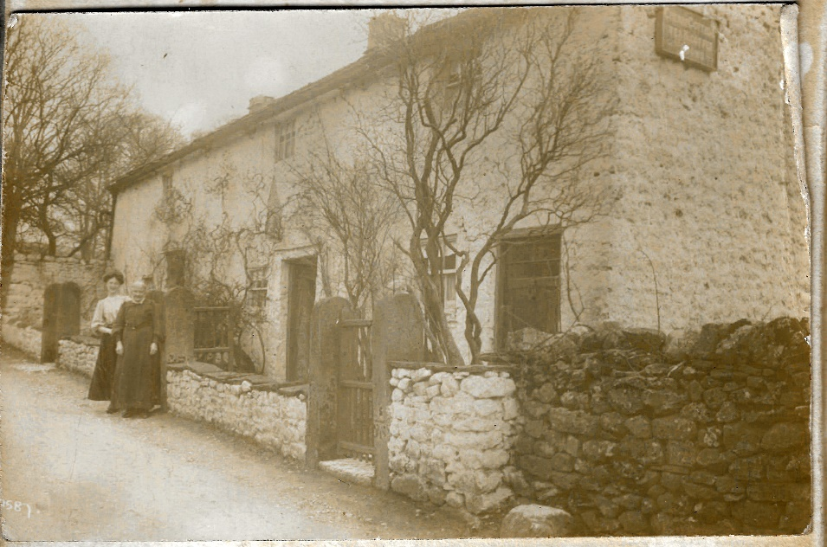
It was in a shocking state, only just holding together, with the engraved plates of Gordale and The Tarn detached and the pages very ragged; but in the front cover was a very faded photograph of Cherry Cottage (Finkle Street) showing the Tearoom sign and two ladies in Victorian dress. There were also newspaper clippings regarding the very rare ‘logographic’ printing process that had been used, whereby complete or part words are assembled in the press instead of separate letters. But the highlight was glued into the back cover, a handwritten note about the recent death of the author’s granddaughter Margaret Hurtley – part text as follows:

Death of a remarkable lady -
On Saturday the 22nd last, a very remarkable old lady, the oldest person in Malhamdale, passed away in her 92nd year, namely Margaret Hurtley of Cherry Cottage, Malham, who kept a refreshment house in the village. She was very active and vigorous until about two years ago, when her hearing began to fail, and she became very deaf and feeble. During the last year her memory was very good, and she was able to tell people about things that happened in her long life. She was the daughter of John Hurtley, printer and book binder, of Skipton (who is credited with having the first printing press at Skipton at the latter part of 1700), and grand daughter of Mr Hurtley of the Old Endowed School at Malham for over 60 years. ……. It is worth recalling that in the beginning of this year, Mrs Turner of the United Schools, Kirkby Malham passed away in her 91st year, having retained all her faculties in a remarkable way, and there are still a few persons in the Dale over 80 years in very good health and vigour. – Friday, May 5th, 1905.

Some of the descriptions in the book are wonderful in their historical context, for example, regarding Malham village:

“The inhabitants are chiefly farmers and alike ignorant of the refinements and inquietudes of the gay world, live in ease and pastoral simplicity. There is a comfortable public house in the village and although the traveller must not expect to find here the luxuries of life, he may at least be sure of meeting with attention and rural fare.”

The Cove – “without question the most beautiful, if not the highest piece of perpendicular limestone in the known world; …”

Gennets Cave – “so called from the Queen or Governess of a numerous Tribe of Fairies which a still prevalent tradition assures us anciently infested it.”

Michael Parker


For details of MLHG’s next meeting see page

