
Misadventure at the Mill
Bill Hall, a Settle doctor, used to live in Scalegill Mill. He passed the following article on to Jen Darling, one of our members, which makes for fascinating reading. It was originally published in the Lancaster Gazette on Saturday 30th March 1861 and highlights the dangers of wearing crinolines which were fashionable at the time.

Crinoline At Fault Again ...

A few days ago, the dangers to which those of the fair sex who indulge in wearing that unseemly article of dress, a crinoline, subject themselves, were manifested under entirely new and disagreeable features. A lady who was on a visit to some relatives residing in the romantic dale of Kirkby Malham was walking along with two female friends by the side of a weir, which supplies the Scalegill mill with water power, the wind, blowing strongly at the time, somehow or other got under her clothes, and, inflating them to more than their usual extent, carried her off her feet, and finally dropped her into the weir, where the depth of water is considerable. Her loud calls for help, coupled with those of her friends, quickly brought two men, who were at work close by, to the spot, and by their assistance, this fortunately rendered, she was speedily rescued from her unpleasant and dangerous situation. We are glad to say that no harm resulted from her immersion beyond a thorough drenching. If our crinoline wearers are to be subject to such accidents, we would suggest the desirability of their carrying with them, when the weather is at all windy, grappling irons, ballast, and such other paraphernalia as is requisite to conduct balloon excursions with safety, in order that, when they are compelled to take their aerial flights, they may regulate their movements in descent with better success, and with less disagreeable results befalling them than those which befell the lady in Kirkby Malhamdale. Correspondent



A very dangerous fashion
Crinolines were popular in the 1850s and 1860s and started out as underskirts made from a stiff fabric woven of linen and horsehair, but they later turned into monsters of wood and whale bone. While crinolines were, in many ways, an improvement on wearing the layers of heavy, starched petticoats previously needed to create the same amount of volume, they came with their own set of problems. While many crinolines were fairly springy, women still had to be aware of how they sat down so as to avoid showing their undergarments or being buried in a pile of ruffles. Crinolines could also be caught in the wind causing the wearer to fall and hurt themselves and their dignity.
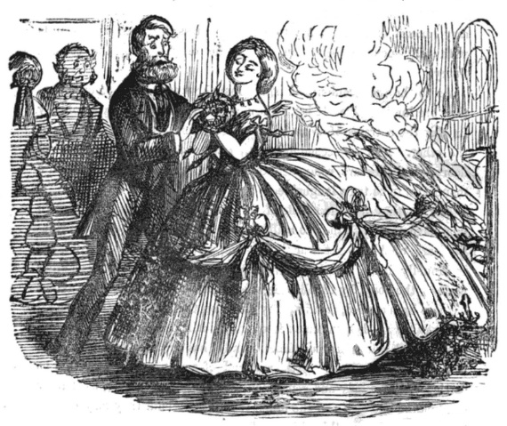
Crinolines also had more-serious safety concerns. It was not uncommon for them to be caught in wagon wheels or machinery, which would at best injure the wearer and at worst kill them. As if that weren’t bad enough, when crinolines were combined with the flammable fabrics of the day, stepping too close to the fireplace could set a skirt alight, resulting in severe injury and, in many cases, death.

Famed nurse Florence Nightingale even criticized the fashionable undergarments in her Notes on Nursing, calling them an “absurd and hideous custom.” She wished that the registrar general would state the number of fatalities it had caused so that women might see how dangerous these garments were.

Adapted from “The Darker Side of Fashion” by Christina Garton, 2019

