Our May talk looked at how village life continued during WW2 and included memories of evacuees. In our archive we have an account from an evacuee who came to Malhamdale.


Memories of Barbara Purcell (nee Hoare) – An Evacuee
In 1940 my family lived at South View Cafe with Mr and Mrs Barratt and her mother, I don’t remember her name. We had a front room downstairs and one bedroom for my Mum and five children, myself aged 8, brother Nicholas 6, brother Noel 4, sister Annetta 2 and my best friend Pauline Harris aged 7. I have no memory about leaving Liverpool or actually arriving at Malham, we just seemed to be at South View Cottage. My Dad would come to visit whenever possible, he had to travel on train and bus, no car in those days, so his visits were quite rare.
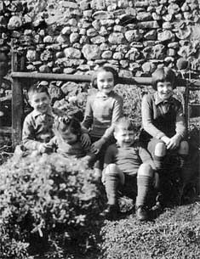
Myself, Pauline and Nicholas went to the school half way between Malham and Kirkby Malham. Our teachers were Mrs Hawkins (headmistress) and Miss Cockerill. They taught children from 5 – 14 years in just two class rooms. I think we integrated very well.

During the winter when it snowed hard it could be 2 - 4 feet deep and the snow plough would clear the road, probably from Skipton to Malham so that the bus could get through, allowing people and children attending the grammar school to travel to work and school.

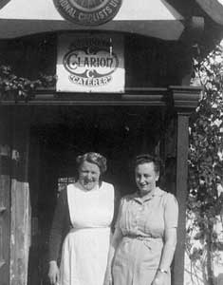

During the summer we had a wonderful time. We used to be taken for nature walks by our teachers and summer holidays we would sometimes help with the haymaking on some of the farms belonging to school friends, this was very exciting for us. There were cattle sales behind the Lister’s Arms Hotel. That was very new to us, sometimes quite frightening – cows are so BIG.

The W I used a room at the library for all sorts of things. My mam joined. They used to put on a play and sometimes a concert. The children were always included. I remember seeing a film with Margaret Rutherford, “The Lady Vanishes”, it was really scary. When the plays, concerts and films were shown and performed, I think it was in a room at the back of the Buck Hotel.
Mrs Barratt (left) and Annie Alderson outside South View.

There is still a blacksmith’s forge by a little bridge, and whoever was the blacksmith in 1940–41 was responsible for some of the happiest times we remember because he made us a real snow sledge. During the winter weekends we all had such fun with it. We used it in the field on the right hand side of the green, opposite the Lister’s Arms. I don’t know who the field belonged to. We would play out there for hours – go home and get changed into dry clothes then go out again. Mostly at weekends of course as it was too dark during the week.

We left Malham I think in 1943. There were still bombing raids over Liverpool and we used to go to the shelters to sleep every night if the sirens sounded.
Linda Hodson

