
A local poet - Christine Thistlethwaite 1933-1920
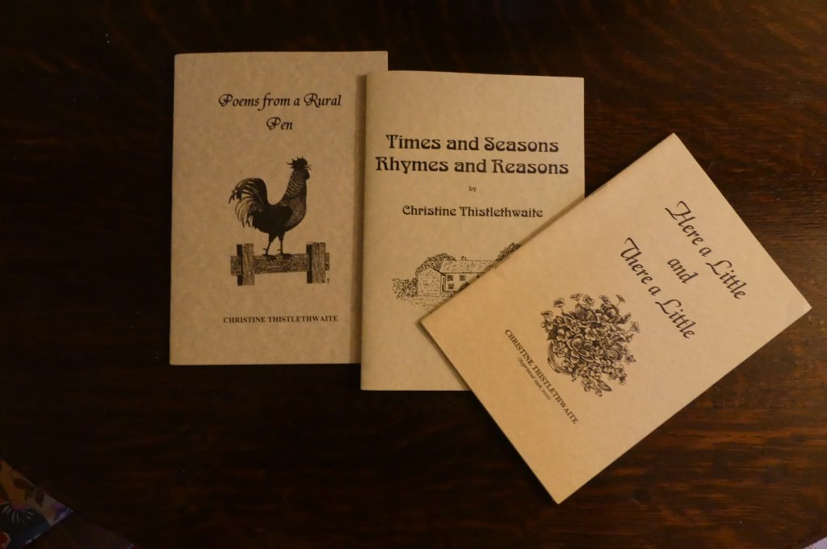
Christine Thistlethwaite was a poet with local connections who sadly passed away during the pandemic. As we were unable to include Christine’s work in our recent exhibition we have decided to pay tribute to her through this article.
Aged just 11, following her mum’s untimely death, Christine went to live with her Granny and Grandad Redfearn at Kirkby Malham which under the guidance of her grandparents, Auntie Amy, and teacher Mrs Turner, proved to be a formative experience. Mrs Turner recognised and encouraged Christine’s talents and vivid imagination, going on to become a lifelong friend and correspondent. Christine always said that she received an amazing education at the village school and although unable to go on to Grammar school, became very learned thanks to her natural intelligence, curiosity and love of books.


Her love of dialect had been sparked when, as a child, she overheard the conversation of farmers on the bus returning from Skipton Auction Mart. A proud Yorkshire-woman, Christine was prompted to pen a poem in the early seventies when changes in county council boundaries meant becoming a reluctant Lancastrian; this was entitled ‘Yorkshire Lad’s Lament’. This opened up her talent for writing Yorkshire Dialect poetry - she would go on to speak at events and publish three books and more recently a CD of her works. Several years ago, she was also honoured to be the guest speaker at the Yorkshire Dialect Society’s Christmas Crack.
Hear Christine’s poems - http://www.gregsonlane.co.uk/christine.htm
Christine met her husband Bert at a dance in Hellifield and she recalled thinking that the young farmer was very handsome. They fell in love and married in 1957 at Bracewell Church. Four children followed: John, Margaret, Roger and Jean, and the family lived at ‘Lower Gills’ in Rimington. Christine worked incredibly hard both outside on the farm and in the home, but she was in her true element: the countryside that she loved, where the bird song and cycle of seasons spoke to her with inspiration for more beautiful poetry.
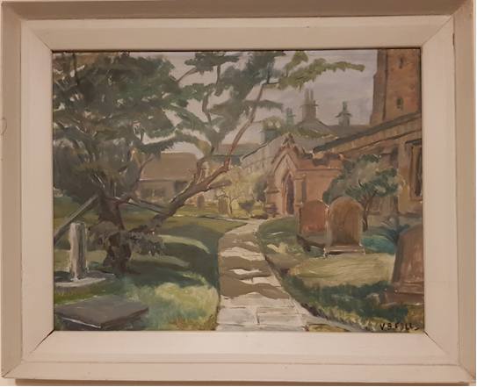
Christine owned this painting of the church. It reminded her of the happy time she spent in Kirkby Malham.
Details provided by Christine’s family in the Order of Service from Christine’s Funeral.

Linda Hodson
Details of MLHG’s next talk can be found on page…

