
A visit to Settle Victoria Hall

In July members of MLHG and guests travelled over to Settle where Josie Guthrie gave us a most informative and entertaining talk about the history of the Victoria Hall.
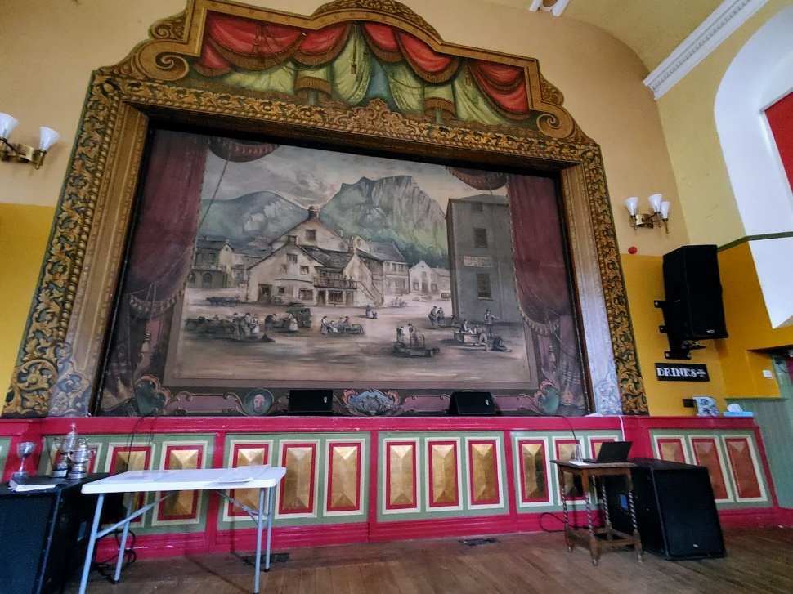

We learned that the first Music Halls were commonly held in the back rooms of pubs but from the 1840s onwards they started to be housed in separate buildings. The Reverend J Taylor, a local philanthropist and member of Settle Choral Society, decided that Settle should have such a building and engaged the architect, Edward Graham Paley, to design it. The fact that the Victoria Hall looks like a railway station building on the outside and a Methodist Church on the inside perhaps tells us the type of buildings Paley was more used to working on.



The Hall was officially opened in October 1853 and is now the earliest and longest-running example of a purpose-built Music Hall still in existence. Despite an initial “Grand Dress Concert” drawing criticism from newspaper reporters, Settle’s Music Hall has continued to thrive to the present day.

The Victorians had very varied tastes in entertainment and this is reflected in the acts that performed in Settle. As well as concerts, recitals and educational lectures the audiences were also able to see many variety acts.
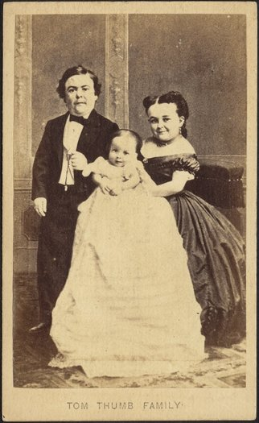
One of the most famous was “General Tom Thumb” who was one of Barnum’s Circus most famous sideshow acts. Standing at less than 3 feet tall Tom was a singer, actor, comedian and dancer who thrilled audiences on both sides of the Atlantic. In 1866 he performed in Settle alongside his wife, Lavinia Warren, and their child. It only came to light at a later date that the child was not theirs at all. Instead, they would “rent” babies from foundling homes to act the part of their child while on tour.

The actdrop or safety curtain that hangs in front of the stage was painted in 1882 by Edmund Handby, a member of Settle Operatic Society. The scene depicts Settle before the Town Hall was built, with a rather mountainous Castleberg Crag in the background. It was an important safety feature as the risk of fire was a real danger due to the use of gas for heating and lighting. It is likely that the painted proscenium arch is also Handby’s handiwork.

See https://www.settlevictoriahall.org.uk/our-history for Josie Guthrie’s full presentation.

Linda Hodson

