
A forgotten tourist attraction

Whilst researching a talk on the buildings of Kirkby Malham I came across this advert for the Victoria Hotel which dates from 1886. It boasts easy access to the well-known attractions of Malham Cove, Gordale Scar and Malham Tarn but also mentions a spa well within 300 yards of the Hotel.
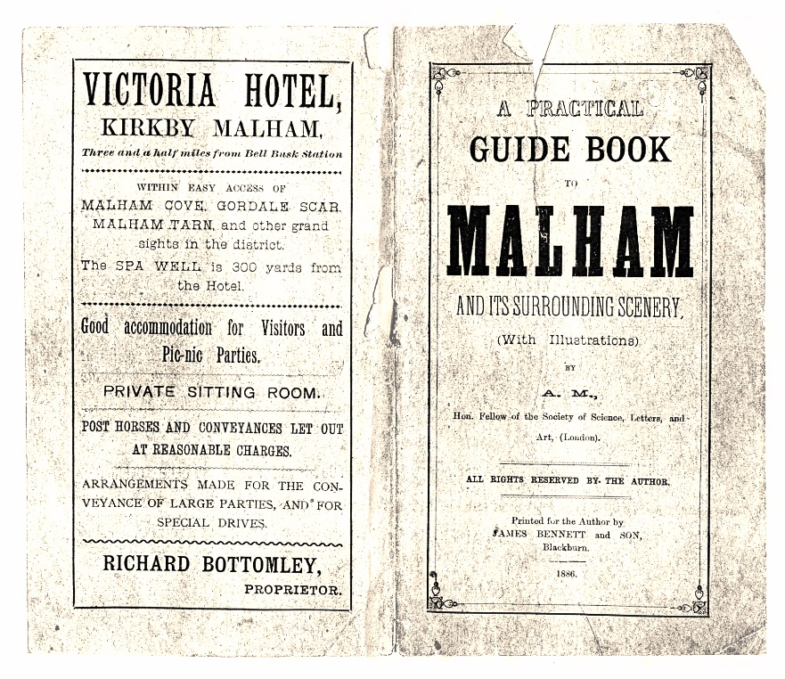

This spa well is mentioned in Harry Speight’s book “Craven and Northwest Yorkshire Highlands” published in 1892. Harry Speight (1855-1915) was a Bradford local historian and genealogist who wrote several interesting books about the Dales and West Yorkshire. His writing is considerably more reliable than the works of many other Victorian authors, though at times a little flowery, and containing some unsubstantiated local tales.


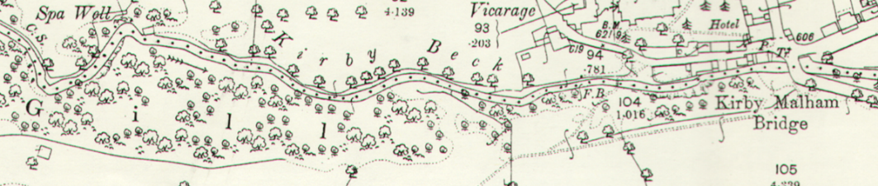
Describing a walk from Otterburn made with Mr W Gomersall, he writes “Crossing Scosthrop Lane, and following the path onward into Kirkby Gill, we descend to the other side of the ravine, where there are deep exposures of the Yoredale beds, with their alternating shales, inclined at a sharp angle in the same direction, north. On the north side of the stream above, where it shallows out, there is an old “stinking” well. The water, which is strongly impregnated with sulphur, is frequently resorted to, and is said to have the same beneficial effects, when drunk, as the waters at Harrogate”.
The site of the well can be seen on this map dated 1892.

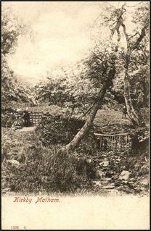
Sulphur was believed to cure many ailments so Victorians were keen to visit places where they could “take the waters”.
No doubt the well’s presence in Kirkby Malham was a welcome boost to trade at The Victoria Hotel.

We have photos of the site in our archive and at least one resident recalls seeing water bubble up from a spring there.
However, apart from Harry Speight’s account little seems to have been written about this well and its properties. I would therefore be most interested if anyone has any information they could pass on to add to our archive.
Please email: mlhgenquiries@gmail.com

For details of MLHG’s October talk please see p.

