
A query from Australia

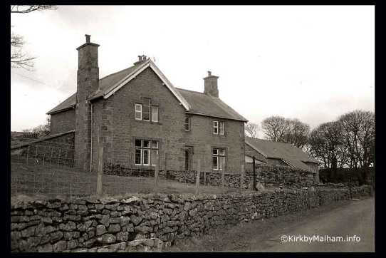
From time-to-time MLHG receives enquiries from people who are researching their family history. Recently we had an email from Sandra Peebles who lives in Australia. Through our website she had discovered that her great grandfather, John Harrison, had farmed at Rainscar Farm and that her grandmother, Gertrude, had been educated at Rainscar School. The school was set up in a room in the farmhouse and operated from 1908 to 1917.
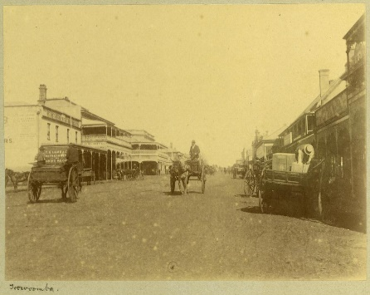
Toowoomba 1897
Austin archive
The Harrison family left Malhamdale in 1911 and emigrated to Brisbane, Australia where they set up a successful sawmill near the fast-growing township of Toowoomba.

Dipping into our archives, we were able to provide Sandra with more information about the Harrisons. Census data quickly revealed them as being prominent figures in Malham. John’s grandfather, William Harrison, was landlord of The Buck Inn between 1841 and 1851. William clearly had a head for business and by 1861 he had multiple occupations: gamekeeper, carpenter and a farmer of 66 acres. His son Henry also worked as a carpenter before turning to farming. By 1871 Henry had married and was farming at Rainscar. Several of his children were born there including John, Sandra’s great grandfather.


However, the family didn’t remain at Rainscar for long. In 1881 they were at New Close Farm, Kirkby Malham and in 1891 at Friar’s Garth, Malham. Moving off Malham Moor meant that the children were all able to attend the new United School in Kirkby Malham.

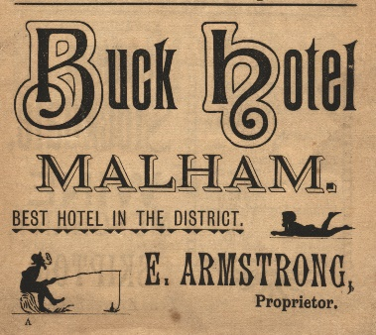
In 1895 John Harrison married Ada Annie Armstrong in St Michael’s. His bride was very much a local lass. Ada Annie’s grandfather, Mathias Armstrong, was the village blacksmith from 1841 to 1871 with several family members following him into the trade. Ada Annie’s father, Edward Armstrong, certainly worked in the Smithy for a while before becoming the landlord of The Buck Inn (1891). Her brother, Edgar, also worked there.

Later, the Armstrongs went on to run the Temperance Hotel in Malham and refreshment rooms at South View.

By 1901 we know that John and Ada Annie Harrison had moved back to John’s birthplace (Rainscar) to farm. Their five children received their education at the little school within the farm, together with two children from a neighbouring farm.

When the family emigrated in 1911 they took a few souvenirs to remind them of Rainscar. Sandra wrote “I have a three photos, Rainscar House with what looks like a family out the front and one of the house in the distance with a wagon of hay being harvested in the foreground. The third is my great grandparents with their eldest daughters. I also have a couple of postcards and an exercise book of my grandmother’s from the school with some heather from the moor in it.”

Sandra is planning to visit Malham in 2025 and hopes to visit the places associated with her ancestors.
Linda Hodson
For details of our next talk see p.

