
A scheduled monument - The Druid’s Altar.
Where is it and what purpose did it serve?

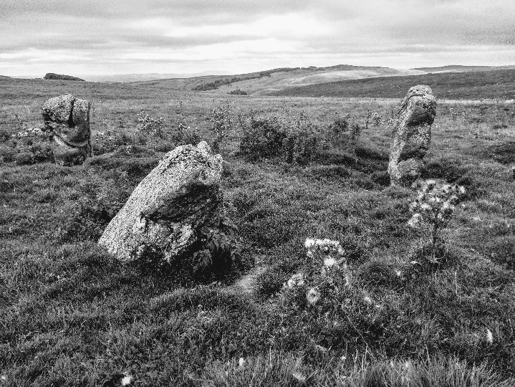

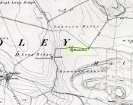
Lying just south of Lantern Holes on the edge of Malham Moor is a small stone circle, known as Bordley Circle or the Druid’s Altar It was marked as such on the local map of 1852 but modern OS maps only show it as a cairn. It is a fairly easy walk to the circle from Street Gate via Mastiles Lane. Alternatively, there is road access from Threshfield via Skirethorns Lane.

The Historic England listing describes the monument as a turf covered earth and stone mound approximately 1m high which measures 13.5m by 10m. The mound has been mutilated by robbing, especially on the south. There are three standing stones situated centrally which protrude through the remains of the mound and reach a height of 1m-1.3m. A fourth stone lies prostrate in the centre of these. The name Druid's Altar derives from the inclusion at one time of a flat stone resting across the top of two standing stones. This is said to have been destroyed many years ago and no reliable record of it remains.
Such stone circles tend to date from the late Neolithic period to the Middle Bronze Age and had considerable ritual importance for the societies that used them. In many instances excavation has indicated that they provided a focus for burials and the rituals that accompanied interment of the dead. Some circles appear to have had a calendrical function, helping mark the passage of time and seasons, this being indicated by the careful alignment of stones to mark important solar or lunar events such as sunrise or sunset at midsummer or midwinter.
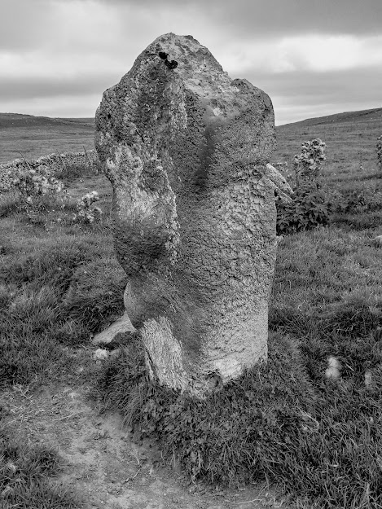
In the case of the Druid’s Altar its function may well have been the latter. Its location is such that it affords views to the distant south and south-west horizons. The setting of the southernmost moon aligns with the outline of Pendle Hill and the setting midwinter sun coincides with Weets Top. This suggests that the site was deliberately chosen by its builders for its astronomical properties.
I hope this inspires you to visit.
Photos by Linda Hodson

