
The legacy of John Gordon Dower
For this month’s article I was prompted by a Facebook Post, from Barrie Arnold, reminding us that this October saw the 75th anniversary of the death of John Gordon Dower in October 1947.
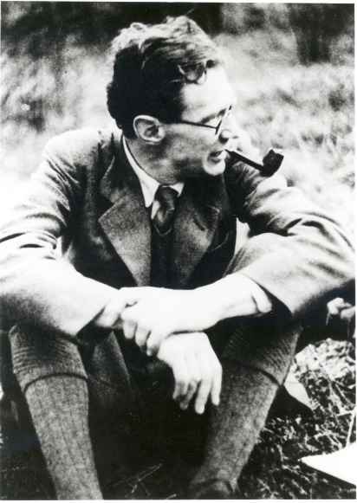
Born in Ilkley in 1900, John Dower’s life and work had a significant impact on the Yorkshire Dales and especially on Malhamdale. An architect, planner, prodigious walker and accomplished writer, he was the driving force that led to the creation of National Parks in the UK and a key figure in the development of the Youth Hostel movement.

Ill health prevented Dower from playing an active role in World War 2. Instead, he was given the task of turning his concept of National Parks into firm proposals. While overcoming opponents both outside and inside government, Dower drew inspiration from the scenery around his rented home in Kirkby Malham (The Rookery). The “Dower Report” was published in 1945 and addressed key questions on the criteria for selecting National Parks, where they should be located, who they were for, and how they should be administered. This paved the way for the 1949 National Parks and Access to the Countryside Act. Ultimately, this led to the Yorkshire Dales becoming a National Park in 1954.
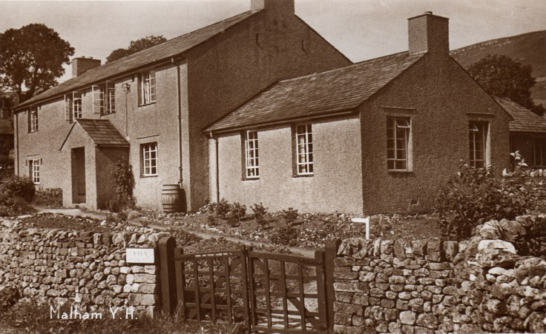
John Dower was also a prominent figure in the Youth Hostel movement and the designer of Malham Youth Hostel. The hostel opened in 1938 and was the first purpose-built Youth Hostel in Yorkshire. It was built on the site of the old Malham Sheep Fair. Funding came from the King George’s Jubilee Trust. The building was designed to echo the style of surrounding cottages and houses in the village and it was popular from the very beginning.
John Dower died from tuberculosis at the tragically early age of forty-seven. However, his work with National Parks and the YHA was continued by his wife, Pauline (nee Trevalyan).
Linda Hodson
For more details about Malhamdale Local History Group see our website www.kirkbymalham.info.

