
The Horner Collection

In March MLHG welcomed Heather Lane, Honorary Curator at the Museum of North Craven Life, to talk to us about “The Horner Collection”. The Collection consists of a group of over 1000 photographs taken by the Horner family who ran a photography studio in Settle from 1864 to 1960. It was acquired by the Museum in 2021.

The photography business in Settle was established by Michael Horner Junior in 1864. This was a time when photography was a new and exciting technology. Michael spent some time working for a Photographic Studios in Manchester before opening his own business in Settle within his father’s shop in Market Place. Thomas Horner was a painter and glazier so the premises must have been quite cramped. By 1865 Michael was advertising stereoscopic images and postcards of local landmarks for sale for the price of one shilling.

Michael used the wet plate method of developing photographs, which was less expensive than earlier methods and reduced exposure times. A wet plate was immersed in a solution of silver nitrate before being placed in the camera and exposed to the light to capture the image. The images were then developed with other strong chemicals. The poisonous fumes may have impacted on his health.
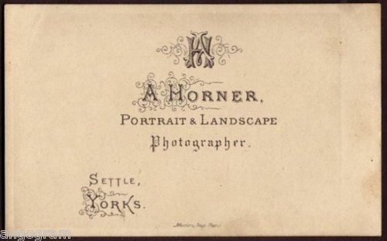
Michael died of consumption aged 26. In 1869 the business was taken over by his brother Anthony, who was only 16. Anthony continued to work in Market Place until 1898 when he moved the Horner Photographic Studio to new premises on Station Road (formerly New Street).

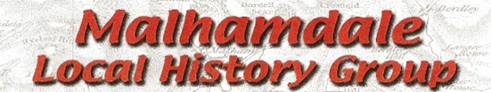

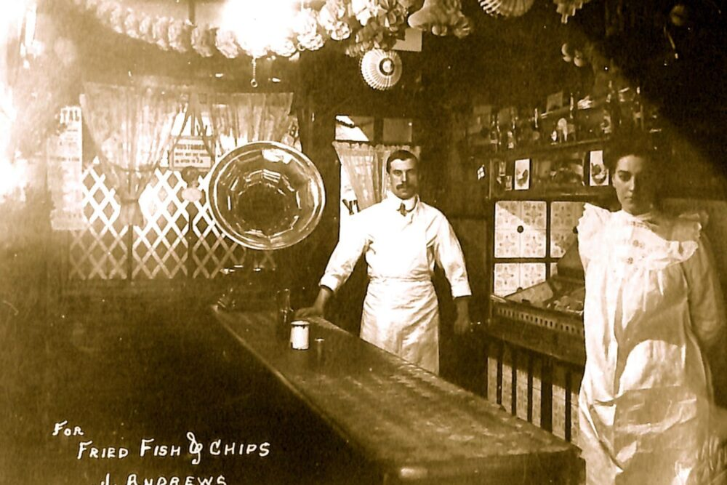
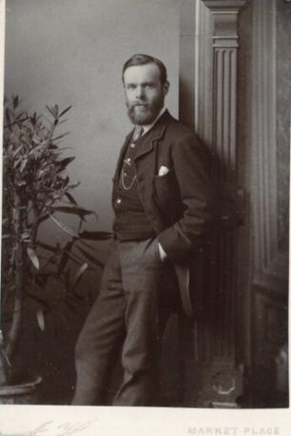
Anthony took photographs of local scenes and events but was especially gifted at family and individual portraits. It seemed that he was able to capture the essence of his sitter, even in a formal setting.

Anthony Horner An advertisement for Fish and Chips

Anthony was succeeded by his son, Edward Holmes Horner, who completed a seven-year apprenticeship with his father. “Eddie” continued to run the business for another 55 years and was well known for his work in the area. He often covered weddings and family gatherings and was even called upon to photograph prize cattle. He died in 1960 and is buried at the Quaker burial ground along with his wife, Winifred.

The business was ultimately bought by Ken and Jean Jelley, who preserved the glass plate negatives which formed the Horner Collection and eventually sold them to The Folly.

What now? Dedicated volunteers are helping to digitise, research and display the photographs to form a permanent exhibition at The Folly. Ultimately, there will be an online catalogue of the photographs which can be used by all.
Linda Hodson

