
The former Malham Café.
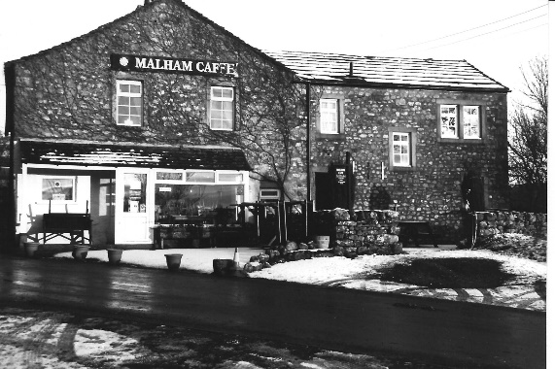
The former Malham Café stands on Finkle St across the road from The Lister Arms. When this photo was taken in 1999 it was still operating as a café. Subsequently it became a private residence and is currently for sale.

A hundred years earlier the building looked very different. There is no extension to the right and the exterior is limewashed. From the signage we can see it was a Temperance Hotel and grocery shop. The proprietors in 1891 were Henry William Clark and his wife Elizabeth. Although a joiner and wheelwright by trade Henry must have been quite an entrepreneur and offered a range of services. The hotel claimed to provide good beds and had a large dining room that could seat 60 people. Transport from Bell Busk station was also offered.

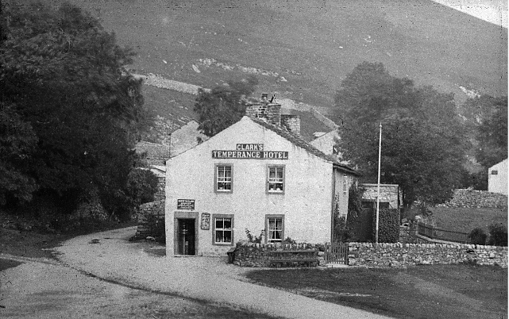
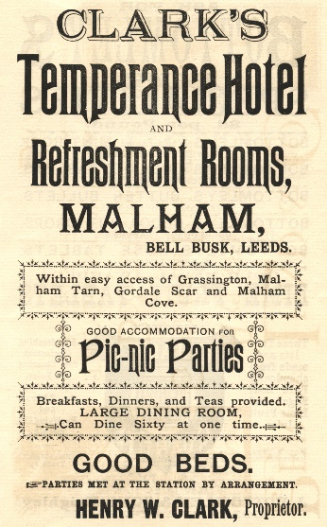
Advertising the Temperance Hotel, 1891.



There was strong support for the Temperance movement within Malhamdale, with both the Wesleyan Methodist Church and the Parish Church setting up Band of Hope groups in the 1870s. Members were enrolled from the age of six, taking a pledge of total abstinence and were taught the "evils of drink". Local "Bands" met regularly to listen to lectures, which included Christian teaching, and to participate in activities such as singing. Music played an important role in the organisation and competitions were held between different Band of Hope choirs. With about 10% of the adult population abstaining from drink by the end of the nineteenth century the Temperance Hotel should have been attractive to many visitors.
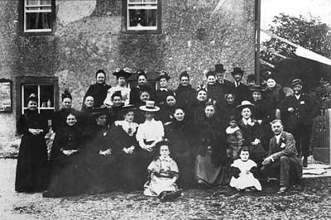

The Airton Band of Hope outside the Temperance Hotel, late 1800s.
As the need for such a movement declined in the 20th century, due in part to the introduction of licensing laws, the Temperance Hotel became Malham Café, providing refreshment to many walkers and cyclists through the years.
Linda Hodson

