
The history of the modern census
With Census 2021 due to take place on Sunday 21st March it seems a good time to reflect on the history of such surveys and their value to us today.
The Domesday Book (1086) – Well known as the first thorough survey of England, the Domesday Book provides a detailed inventory of land and property. However, unlike the modern census, it did not provide an accurate count of the people living in England at that time. Its main purpose was to establish the ownership of assets, so that owners could be taxed on these possessions.
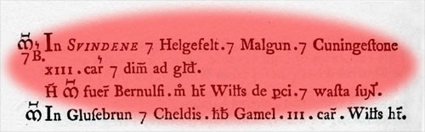
The earliest written references to Malhamdale Townships can be found in the Domesday Book.
In Swinden, Hellifield , Malham and Coniston [Cold] there are 13 and a half caracutes taxable. Bjornulfr had the manors. Now William de Percy has [them] and they are "waste". (Rough pasture or perhaps “laid to waste”).
The Hundred Rolls (1279) – This survey painted a more detailed picture of rural society than the Domesday survey and included some information about those living in the townships. Unfortunately, nothing was done with the results of the survey and there are no surviving records for our area.
The Census Act, 1800 – There was a reluctance to collect further national data until 1800. At this time concerns were raised that population growth would soon outstrip supplies of food and other resources. To mitigate against this Parliament passed the Census Act to determine the true population. The first census took place in March 1801 when statistical information was collected but no personal data. This confirmed the population of Great Britain as nine million.
Population figures for Malhamdale Townships in 1801
Township | Mal Moor | Malham | Kirkby M | Scosthrop | Airton
Pop. 1801 | 98 | 262 | 167 | 90 | 139
This data tells us little on its own but when it is compared with subsequent years we can chart the rise and fall in the population within Malhamdale and begin to find reasons for it. A full dataset can be found at http://www.kirkbymalham.info/KMI/malhamdale/population.html
The modern census (1841 onwards) – Census data has been collected every ten years since 1841 apart from in 1941, during the second World War. Census data, over 100 years old, is freely available for researchers to use and paints a fascinating picture of communities in the past. All the data for Malhamdale townships (1841 to 1911) can be found on our website www.kirkbymalham.info
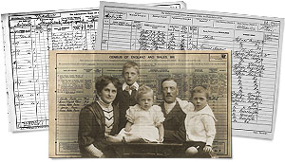
NYCC library service offers support with genealogy and family history and gives access to Ancestry.com and FindMyPast.co.uk

