
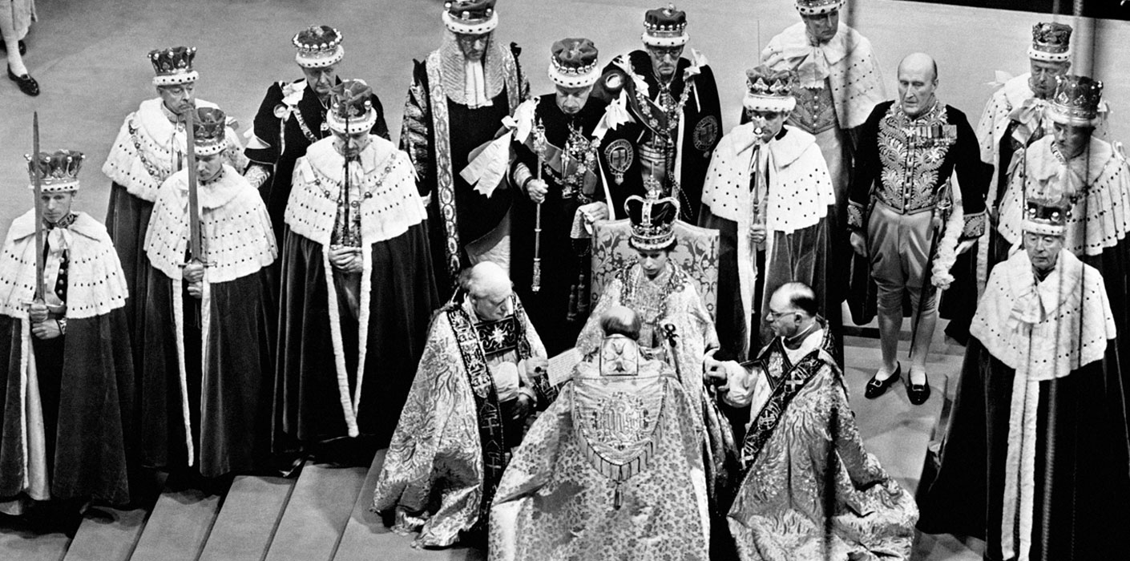
Memories of Coronation Celebrations 1953
Queen Elizabeth II was crowned in Westminster Abbey on June 2, 1953. Her coronation was ground-breaking as it was the first to be televised, allowing millions of people to watch the ceremony in their own homes. 27 million people are believed to have tuned in, whilst millions more watched from around the world.

The Craven Herald reported that “Three television sets were installed in Skipton Town Hall for residents who were aged 65 or over… The old folk were thrilled by everything they saw. Reception could not have been better. The images were sharp and clear. The commentary by Mr Richard Dimbleby and his colleagues bore the stamp of perfection.”

Marion Wellock and Joan Barker both recall seeing the ceremony on television. Marion, who lived at Garris House Airton, went with her family to watch the coronation service at Garris Croft, the home of Margaret Dewhirst. Very few families owned a television so Marion remembers the room being very crowded.



Joan Barker of Grove Farm, Otterburn remembers that her parents had bought a new twelve inch black and white television. The Barkers were joined by the Taylor family, from Wenninger Farm, to watch the proceedings.
Coronation Day dawned very wet and miserable. Marion’s first memories of the day were of having her photograph taken with her sister outside their home. They had new dresses made of blue nylon seersucker. She remembers they were very cold in the flimsy dresses.
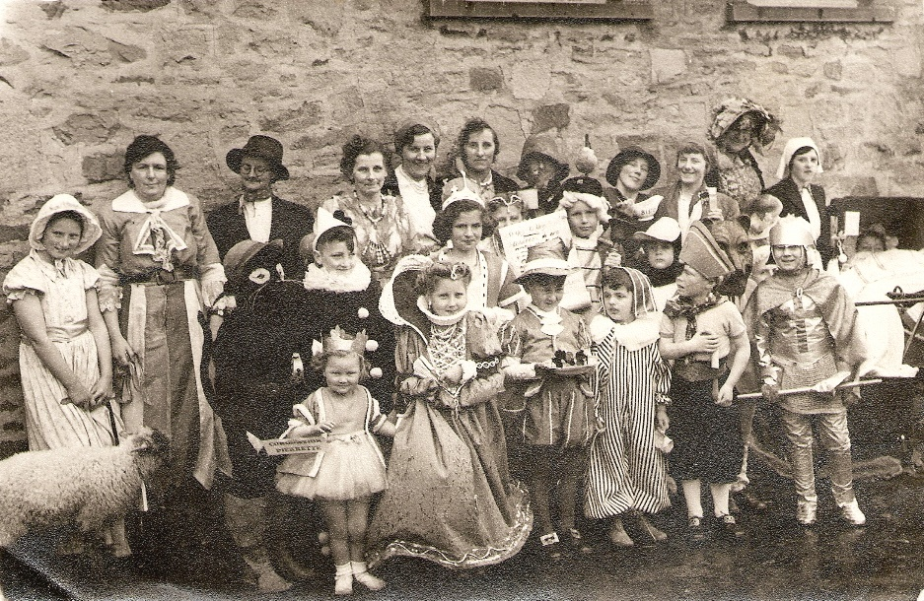
A street party had been planned but the weather was so bad that everyone crowded into Airton School where there was a lunch and games were played. The outside events were held a couple of days later with a fancy-dress parade followed by games and a dance in the Scosthrop schoolroom.
Airton residents in fancy dress outside Airton School.
Linda Hodson. For details of MLHG’s June talk see page

