
Winterburn Reservoir

Following on from David Turner’s excellent talk on “The Building of the Barden Moor Reservoirs” I decided to take a closer look at the history of Winterburn Reservoir.

Constructed between 1885 and 1893 its purpose was to maintain the water levels on the Leeds and Liverpool Canal, which were often too low during periods of drought.

The ”History of Winterburn” section of www.kirkbymalham.info provides details of costs and size.

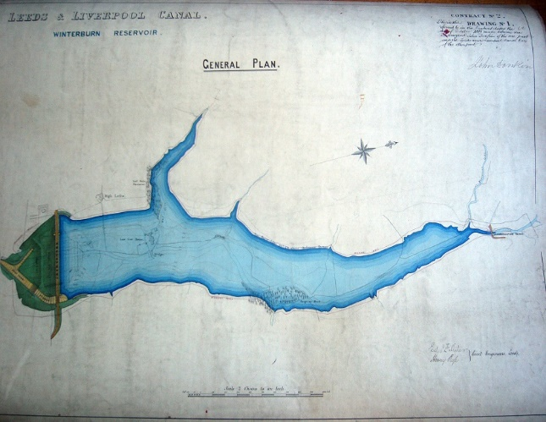
1882 - The estimate for the reservoir which was to hold 3,550 locks full of water, was £45,000. The work was supervised by consulting engineers Filliter and Rose and built by Oxenhope contractors Messrs Crabtree Bros. The reservoir covers an area of 40 acres and has a holding capacity of 281 million gallons.

The record goes on to state “Lower Cow House should be in the middle of it unless it was demolished.”

Much of the work would have been carried out by navvies with up to 200 working on the site. Some lived in huts close to where the reservoir was being constructed whilst others lodged further afield. The 1891 census provides details of those living in Winterburn.


The census has records for six huts accommodating the following workers: a Foreman navvy, four navvies, four general labourers, a joiner, a bricklayer and two stonemasons. Wives and children also lived in these huts. Thomas Wadsworth, Inspector of Reservoirs, Thomas Palmar, Inspector of Bricklayers and William Page, Inspector of Navvy Work were also listed.

Records confirm that conditions for the navvies were primitive and smallpox broke out in 1888. Skipton Rural Sanitary Authority complained so the contractor erected a hospital with furniture provided by the company. This was situated above the reservoir on the track to Hetton. There were further outbreaks in the following years.

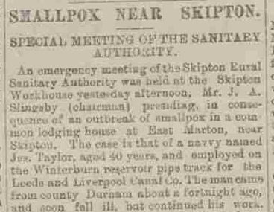
A report in the Burnley Express in January 1893 reported an outbreak of smallpox in a common lodging house in East Marton. Jos Taylor, a navvy working on the Winterburn pipe track, fell ill but continued his work. Twenty six other navvies were housed at the property with three other men sharing a room with Taylor.

The reservoir was officially opened in August 1893 and was the last major construction project of the canal. It was connected to the canal by a 14km long pipeline, discharging at Greenberfield.

More than 130 years on, Winterburn Reservoir still plays a crucial role in supplying the Leeds & Liverpool Canal with water. “Our reservoirs feed our canals and maintain water levels along the inland waterways, a function that is proving increasingly important as we face the challenge of climate change.” Stuart Sutherland, Canals and Rivers Trust.

Linda Hodson

