
Sundials in Kirkby Malham
Like many of the surrounding Dales villages Kirkby Malham has many interesting datestones and inscriptions on its buildings. However, it also has several sundials which is more unusual. Two of these can be found on public buildings and one on a private dwelling.
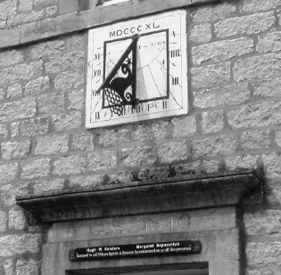
Perhaps the best known of the three sundials is above the door of The Victoria Inn.
Soon after inheriting the family estate George Serjeantson of Hanlith Hall had a new Hotel built to replace an earlier inn called The Sun. He had his initials GS and 1840 engraved over the door and incorporated a dated sundial with a decorative gnomon.

For the full story behind this sundial and the history of “The Vic” go to www.kirkbymalham.info/KMI/kirkbymalham/victoria.html
How do sundials work?
Sundials work by the sun casting a shadow on the sundial’s gnomon. When the sun is at its highest point of the day, or midday, the shadow is the shortest. When the sun is lower, in the afternoon, the shadow is the longest. Sundials are usually well marked with daylight hours, and there are some that have all 24 hours marked on them.

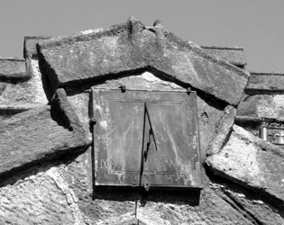
A second sundial can be found on the church porch. Why did the church need a clock and a sundial? It is thought that although the church tower housed a clock in the 18th century it probably wasn’t that reliable and the sundial would provide a means of setting it.


Fact: Up until the early 19th century sundials were the main instrument people used to tell time. If they are correctly placed, sundials can be used to accurately tell time down to the minute!
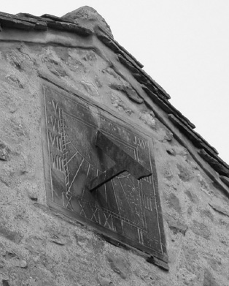
Many will either walk or drive past the third sundial without even noticing it is there. Situated on the southern gable of Hannah's Cottage or No.1 Main Street, this sun dial bears the initials JW, that of John Walker, a previous owner of the house. The dial plate is otherwise very similar to the one on the "Vic" and is likely to be from the same maker. It is thought that this may also date from around 1840.

If you know of any more sundials in Malhamdale let us know. Email.MLHGenquiries@gmail.com

