
Walter Morrison honoured with blue plaque
Anyone walking through Malham since Christmas will have noticed that there is a new information panel and a blue plaque outside the village hall. These two items were unveiled in December as a tribute to the life and work of Walter Morrison.
It was fitting that the unveiling took place on 18th December 2021, exactly 100 years after Walter Morrison’s death.
Sponsored by the Malham Village Hall Committee, the plaque has been supplied by The Yorkshire Society and was unveiled by its deputy chairman, Geoff Walsh. Neil Heseltine, chair of the Yorkshire Dales National Park Authority, revealed the accompanying information panel, which provides further details of Morrison’s life and work.
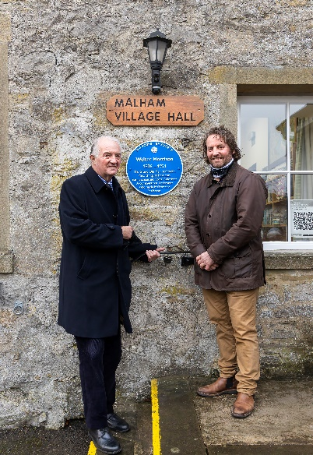
Walter Morrison lived at Tarn House, Malham and was an MP, businessman and philanthropist. He contributed to many projects within Malhamdale including the refurbishment of the church, the building of Kirkby in Malhamdale Primary School and the provision of a reading room which is now Malham Village Hall. He also financed the printing of thousands of copies of “Craven’s Part in the Great War” and funded the building of Giggleswick School Chapel.



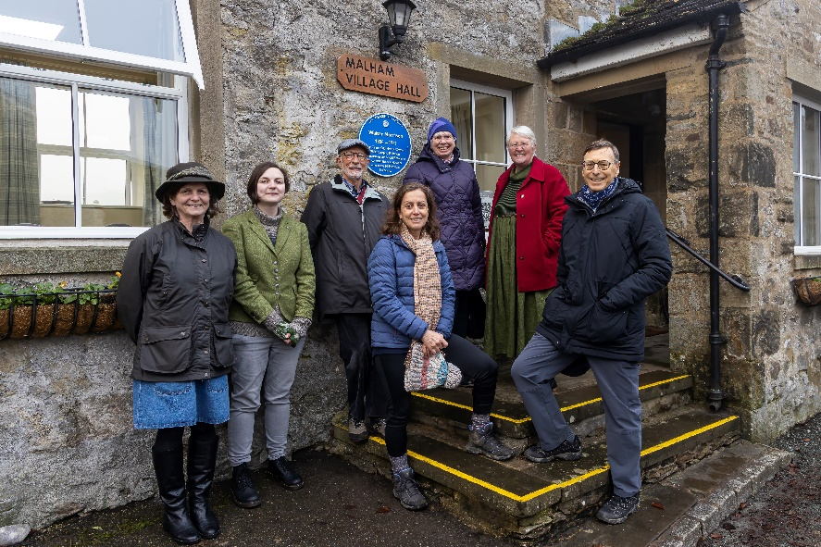
The unveiling ceremony was attended by local residents, together with members of the Walter Morrison Festival Committee who had organised exhibitions and lectures throughout the summer, as well as devising a walking route “The Walter Morrison Way”.
If anyone has not yet seen the Walter Morrison exhibition in full it will be on display at The Folly in Settle until February 19th.
There will also be a chance to hear Robin Bundy give his talk on “Walter Morrison – The Grand Old Man of Craven” in Kirkby Malham Parish Hall on Thursday 17th February at 7.30pm.
Details of “The Walter Morrison Way” walking route can be found at https://thefolly.org.uk/walter-morrison-festival/the-walter-morrison-way/
Linda Hodson Photos courtesy of Matthew Jackson

