
Kirkby in Malhamdale United School

As the school celebrates its 150th anniversary I thought it would be interesting to take a look through the log-book. The new United school had been open for a term when its first Christmas approached. The entries for December 1874 refer to examinations taken rather than any Nativity Plays or other celebrations. Conditions for learning were far from good due to lack of heat in the building.

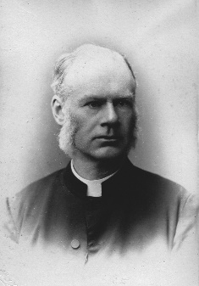
1874
Wed 23rd December – A thermometer was brought to the school on Monday by the Rev. T.C. Henley. At 8.15 it registered 32F but at 9 it was 39F when the school opened.

Thurs 24th December -The school broke up for a fortnight’s holiday. The 1st class wrote letters to their parents (not Santa!).

In December 1875 the children ended up with a much longer Christmas holiday due to the illness of teachers and children.

1875
Thurs 2nd December – The Chairman and several governors visited the school and considering the illness of the Master and the present small attendance in the school, consequent partly upon parents’ apprehensions of infection, decided on closing the school from tomorrow until Monday January 3rd for the Christmas holidays.

Friday 3rd December – James Carr has assisted Mrs Hicks in teaching this week. All the children have behaved very nicely. The Master sent a letter to the children which Mrs Hicks read to them. The school broke up for a month’s holiday, the usual time being a fortnight.


An entry in December 1877 reminds us that misdemeanours were harshly dealt with.

WP was convicted of meddling with the boys’ dinner bags and part of a pasty was found on him. He has long been suspected of pilfering, as it always occurs when he is at school (half-timer) and he goes out to attend the fires. He had four cuts with the cane.

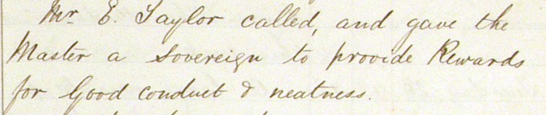
However, there were rewards too, provided by school governors.

Very best wishes for Christmas and the New Year from all at MLHG.


Forthcoming meetings
Tuesday 10th December 2024
MLHG Annual Dinner for members and guests.

Thursday 16th January 2025
Village Diaries – a look back at 2024
Plus contributions by members.

7.30pm at Kirkby Malham Parish Hall.

