
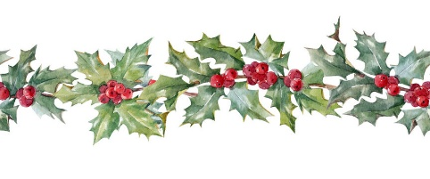
A Christmas Greeting from the Past
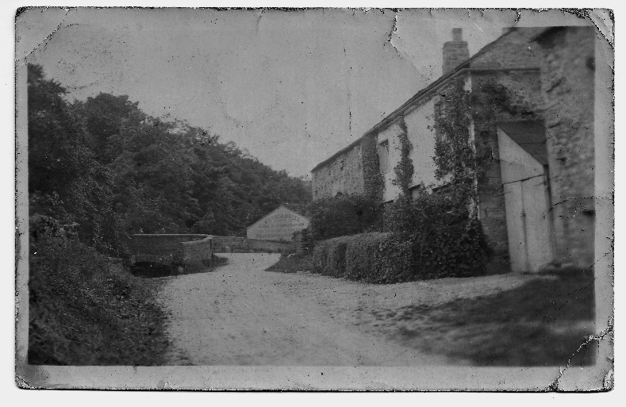

From time to time the history group purchases old postcards which have local relevance to add to our archive. Earlier this year we came across this view of Kirkby Malham. It was taken from Greengate and shows Yeoman’s Cottage and Barn on the right with the bridge on the left. Across the road there is advertising for The Victoria on the gable end of the building that is now Albert Cottage.

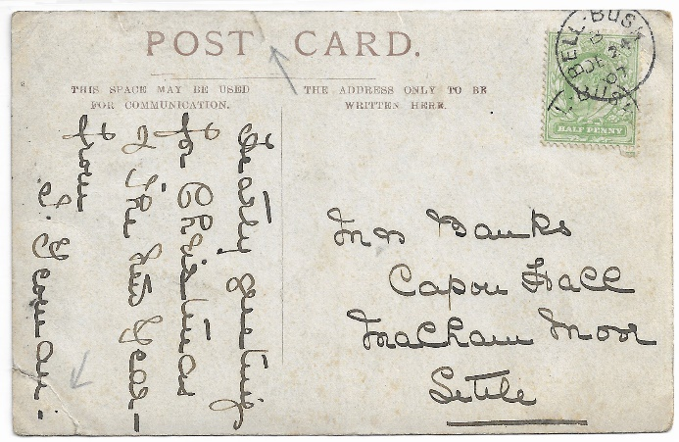
However, what made it more interesting was the greeting on the reverse. The card had been sent as a Christmas card to Mrs Banks at Capon Hall, Malham Moor and was from Miss I Yeoman. It was postmarked 24 Dec 1907.



The sender – Local records helped to establish that the sender was Isabel Yeoman who was born in Scosthrop in 1876. Her parents were William Norman Yeoman (farmer) and Catherine Yeoman. By 1891 the family were living in Kirkby Malham on Greengate, presumably in what is now known as Yeoman’s Cottage. Isabella was living at home and was a pupil teacher at Airton Board School.

Isabel qualified as a teacher and worked at Hellifield School before being appointed as Schoolmistress at Malham Tarn School in 1898. She taught there for six years before moving on. This card was sent some two years later.

The recipient – Mrs Banks was Margaret Banks (nee Parker). She married Abraham Banks in 1884 in Kirkby Malham. They then moved to Capon Hall where they lived and farmed for many years. Isabel would have known Margaret from her time at Malham Moor School, which may account for the Greetings but it is equally likely that the two women were simply friends as they were both from local farming families.
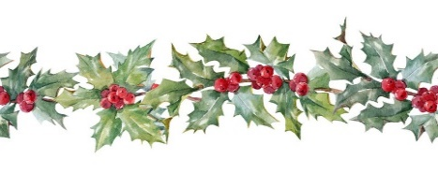
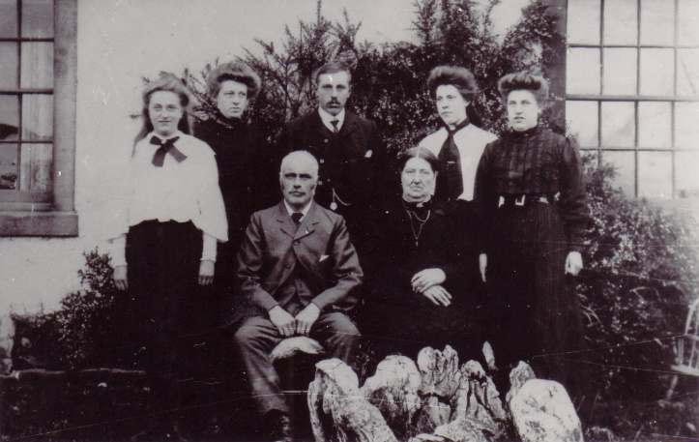

Pictured – Abraham and Margaret Banks and family at Capon Hall

Very best wishes for Christmas and the New Year from all at MLHG.

