
Letters to Father Christmas from 50 years ago.
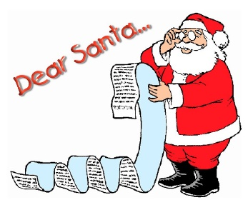
In our archive we have a compilation of letters written by children at Kirkby Malham Primary School c.1972/3. The piece is entitled “Parents take note….” It is interesting to see what the children were asking for and how the letters reflect the economic difficulties of those times.
This Photo by Unknown Author is licensed under CC BY
Dear Father Christmas………

From Julie aged 10
If you take the trouble to visit me this year, I would like a skirt and several little things like that… I would like some books because I have read all my others a million times. All my jumpers are too small except one I don’t really like. A few sweets wouldn’t be unwelcome – are they ever!

From Catherine aged 10
For Christmas I want a ball and a back light for my bike. I want a back light because Mother won’t let me go out at night.

From David aged 8
Will you bring me a penknife because my other one is blunt and won’t cut properly.

From Adrian aged 8
I would like an electric torch because when mum goes out we have to stay at the Centre until Dad stops work then we have to walk down in the dark. And I could read with it in electricity cuts.

From Nicola aged 8
I would like £5 as it would not have to be packed. My next one is not a present – it’s a wish. Keep Daddy happy out there till we join him.



From Bridget aged 10
I hope you will visit me with a big sack of surprises. I don’t really know what I want but I would like a few exciting books because I love reading. When I was at Pony Club Camp I lost my hoof pick. May I have one please? Can I have a penknife because it would come in useful for cutting balls of string. My hair clips are always getting lost so they might come in handy. Sorry I haven’t many ideas.

From Joanna aged 7
I would like a book named Milly Molly Mandy and if you make them a French and English dictionary.

From Penny aged 10
I would like a record token… I have been trying to be a good girl. I am in need of a new pair of shoes very badly.

From Martin aged 8
I want two packets of stink bombs because Tim let off some stink bombs in my bedroom.

From Helen aged 6
Please will you bring Mummy some perfume and bring Simon a farmyard. Please will you bring Daddy a bow tie.
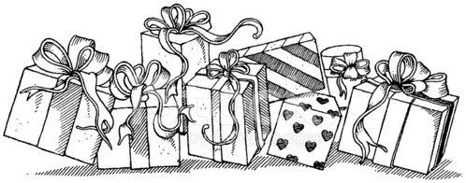

Many thanks to all those who have attended MLHG events this year or who have supplied items and information for our archive. We look forward to seeing you in 2023 when we have more interesting talks planned.
Linda Hodson

