
The Hurtleys of Malham
Following last month’s introduction to the Hurtley family in Michael Parker’s article I undertook some further research with some fascinating findings.

Thomas Hurtley 1748-1830
Thomas lived all his life in Malham, marrying a local girl, Nancy Hird, in 1773.
He was the schoolmaster at Malham Free School for over 60 years, retiring at the age of 81. Charity Commission reports confirm that Thomas provided a good standard of education to children in Malham during this time. He was well versed in classics, a keen admirer of nature, a graceful writer and a well-read man generally. Thomas is best remembered as author of ‘A Concise Account of the Natural Curiosities of the Environs of Malham, in Craven, Yorkshire’. This book was published in 1786 through public subscription. It is known that the project was supported by Thomas Lister, 1st Baron Ribblesdale. Some suggested that it was radically edited by him too. Certainly, Lister doubled the number of subscribers, then applied radical ideas to the book. He had the plates drawn and engraved at his own expense.
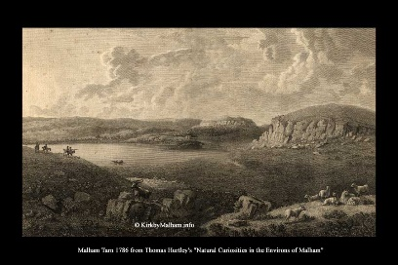
The verses that were the principal part of the book were totally omitted “and there were so many additions and alterations in the descriptive part that it is supposed that there is not a line remaining as it came out of the hands of honest Thomas Hurtley”.

John Hurtley 1787 -1856
Thomas Hurtley’s son John also lived in Malham in his later years. He is listed on both the 1841 and 1851 census forms as being a widower with an independent income. His household included his oldest daughter Margaret and her children.


However, if Thomas Hurtley could be described as an honest man, the same cannot be said of his son. The York Herald reported on the following case in May 1849.
“A man has been apprehended in Manchester, who has been preying on the nobility and gentry of this country for the last five years and duping them of their guineas under a pretence that some time ago they have put down their names on his subscription list for a new work he had published under the title ‘The Beauties of Yorkshire’.”
The prisoner was identified as John Hurtley from Malham in Yorkshire, the owner of a small estate which brings him in about £40 a year.
The fraud worked because many of those Hurtley wrote to simply paid up. However, there were some who had questioned the requests and eventually the matter was handed over to the police. Letters and papers found in Hurtley’s possession confirmed that attempts had been made to obtain money through deception. Those targeted included MPs and members of the nobility including the Earl of Harewood, the Duke of Devonshire, Lord Grantham and the Archbishop of York.
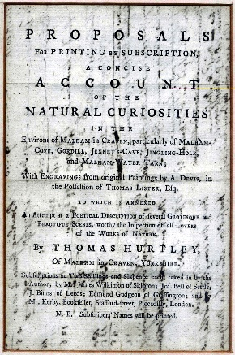
In his defence the prisoner said he had only written to those who had subscribed to his father’s book and that his intention was to print a second edition.
A lucky escape?
Whilst the police were able to furnish evidence that Hurtley had practised fraud for a long time and had obtained at least eighty-nine guineas through false pretences they were unable to persuade any of the injured parties to attend the hearing in Manchester on behalf of the prosecution.
The magistrate had no option but to dismiss the case and the prisoner was immediately set at liberty.
We can only presume John Hurtley returned to live in Malham until his death in 1856. His burial took place in Kirkby Malham.
Linda Hodson
Next month – Find out more about Margaret Hurtley.

