
Invitations to the Coronation in 1953
Joan Hassell, a wood carver and illustrator, gained an important commission in 1953 as the result of winning a competition to design invitations for the coronation of Queen Elizabeth II. Joan’s winning design was sent out to 8000 guests. However, one very important guest, Prince Charles, received a child-friendly invitation, also produced by Joan.
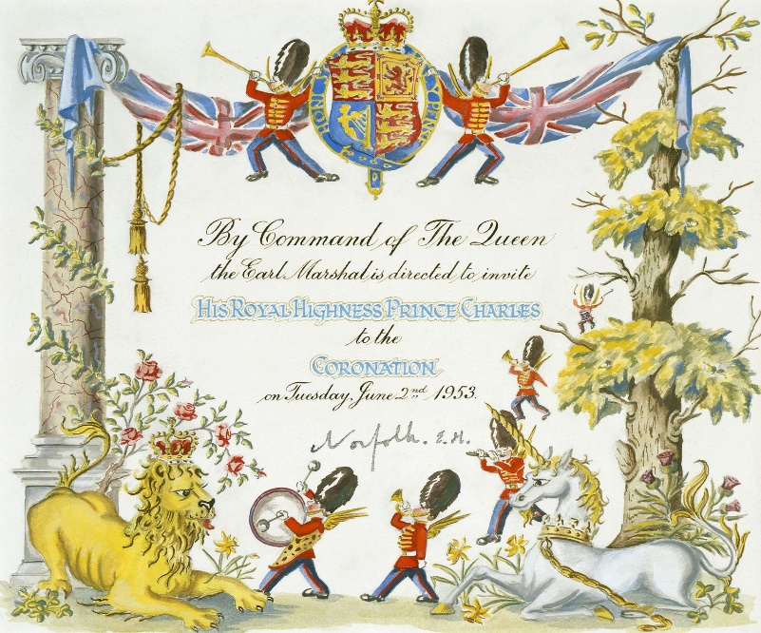

Image: Royal Family
Joan had connections with Malham most of her life and in 1973 she moved to live in Priory Cottage which she had inherited from a friend. The time spent in Malham until her death in 1988 was said to be the happiest period of her life.
Learn more about Joan’s life and work at the MLHG Exhibition on 2nd and 3rd April.

